# **HTTP Host header attacks**

So In This report we are going to learn HTTP Host header attacks in simple way

**What is mean by Http Host Header Attacks?**

An **HTTP Host Header Attack** happens when a hacker manipulates the "Host" part of a web request.

### **Scenario:**

Imagine you are visiting a banking website, like **bank.com**, to check your account balance. When your browser sends a request to the bank's server, it includes a **Host header** like this:

**GET /account HTTP/1.1**

**Host: bank.com**

This tells the server to send the correct page for **bank.com**.

### **Host Header Attack:**

Now, an attacker discovers that the bank’s server doesn't check the **Host header** properly. They change the request by modifying the **Host** value to something else, like:

**GET /account HTTP/1.1**

**Host: evil.com**

If the bank’s server is vulnerable, it might accept this request and process it as if it were for **evil.com**, potentially:

1. **Redirecting users** to a fake version of the banking site (evil.com), where they can steal login credentials.
2. **Sending a password reset link** to a wrong or malicious site controlled by the attacker.
3. Showing **confidential data** (like user accounts) to the attacker’s website.

### **Real-world outcome:**

The attacker can trick the bank's server into:

* Displaying sensitive info on **evil.com** instead of **bank.com**.
* Redirecting legitimate users to a phishing site where their details can be stolen.

### **Solution:**

The bank's server should check and ensure that the **Host** header is always **bank.com** and reject or correct any requests with other hostnames.

This is how a simple manipulation of the **Host header** can lead to major security risks if not properly handled!

So thats the example for It.

**We take examples as portswigger labs of HTTP Host header attacks**

**AND Right now we are going to solve them as one by one**

**1)Basic password reset poisoning**

This lab is vulnerable to password reset poisoning. The user carlos will carelessly click on any links in emails that he receives. To solve the lab, log in to Carlos's account.

You can log in to your own account using the following credentials: wiener:peter. Any emails sent to this account can be read via the email client on the exploit server.

So lets access the lab:-

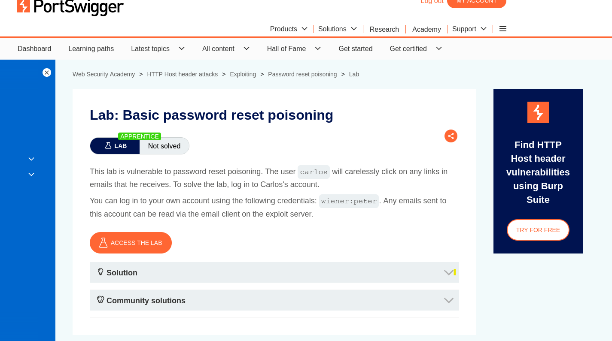

**Step:1**  
By clicking Access The lab We Get the Web Interface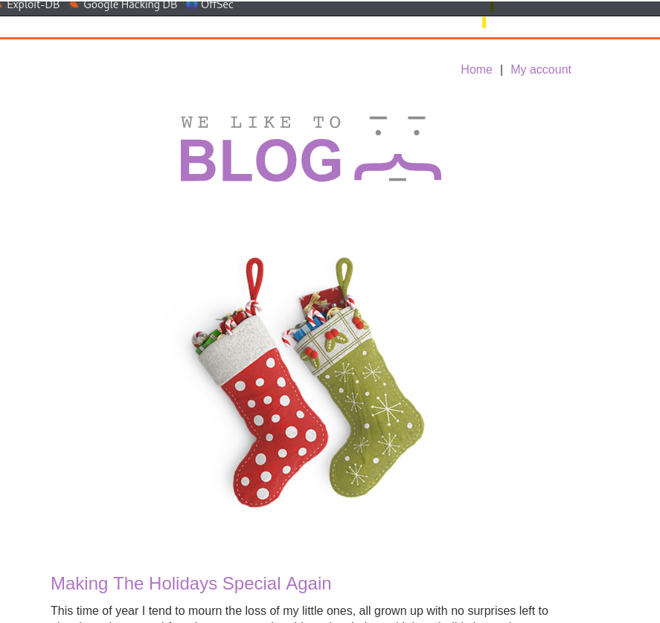

**Step:2**

Lets Go To login And   
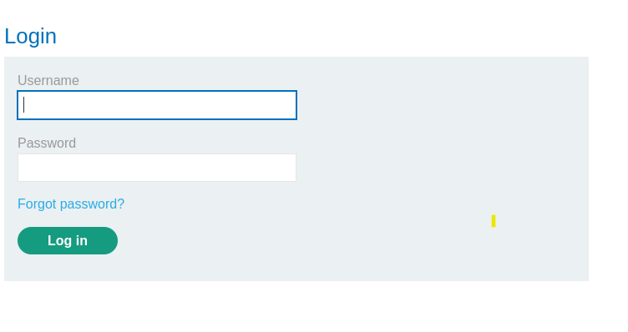

Click on forgot password, We Get interface like this

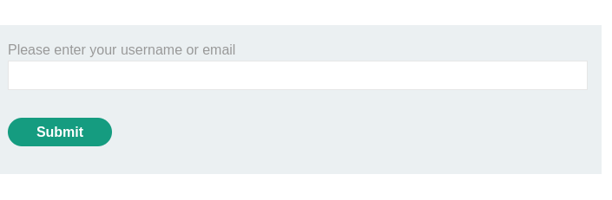

We get like this give user name as wiener and click on submit button

**Step:3**

So next we get as

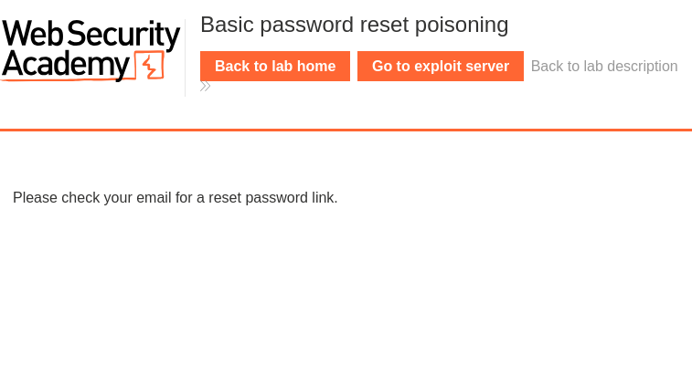

Like this so next

Go to exploit server Click On it

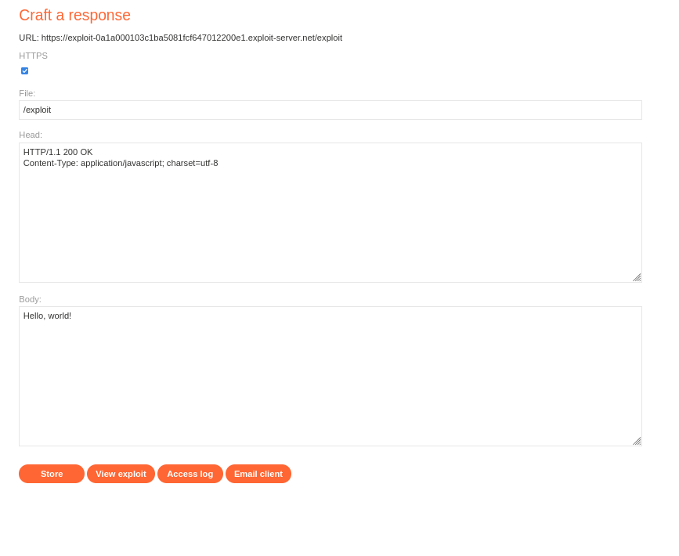

Here We crafted a response so at the bottom we see that

Store,View Exploit,Access log and Email client

**Step:4**

Click on Email client,We get the interface like this

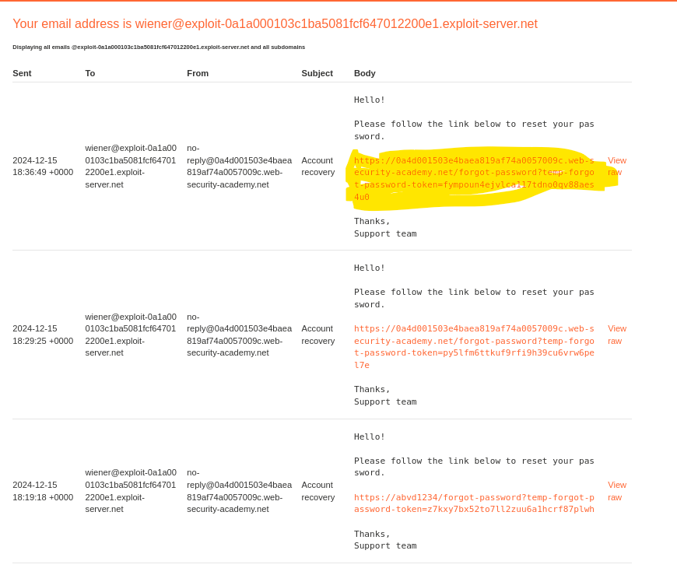

**Step5:**

Click On The Marked Link And Change the Password as you need.

Note:While doing your practical you dont get same link You get your own link

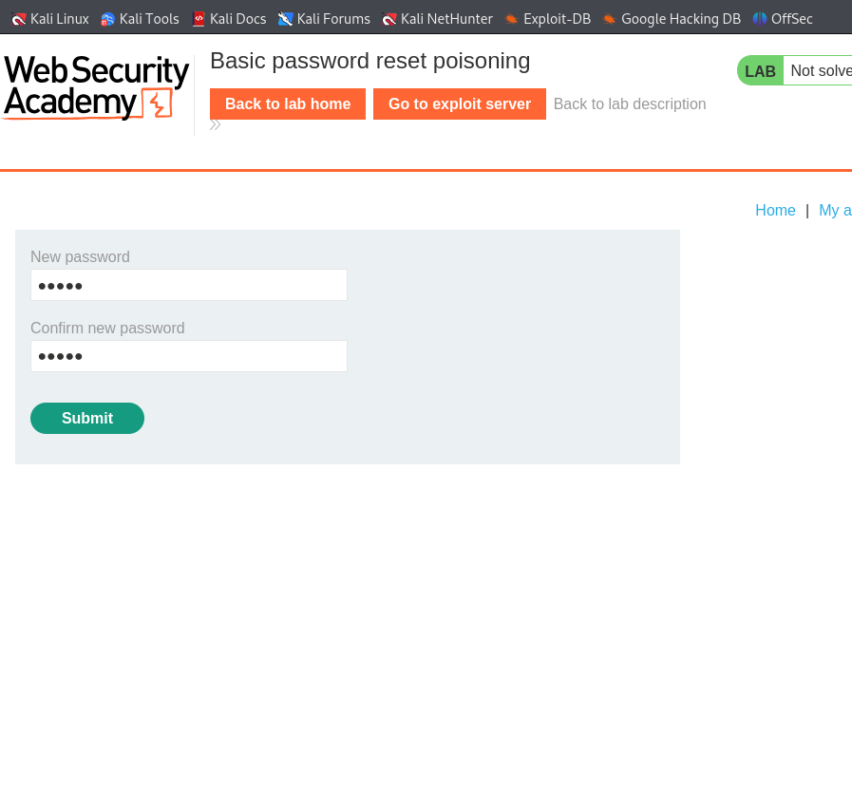

**Step:6**

Next In Burp>>Go TO HTTP history>>And Chcek for /-forgot-password

Click on it you see the request response. Like in the image it shown

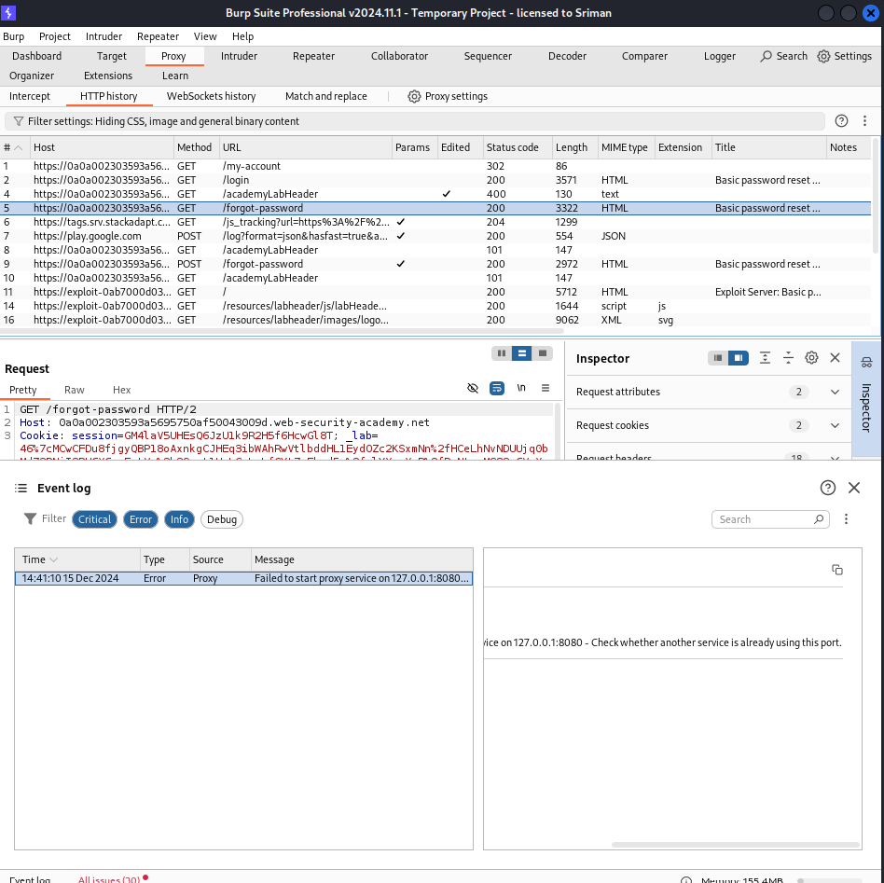

And Now Send This Request to burp repeater..

**Step:7**

Switch To repeater

Change the Host header as you like

I changed it as Hello123

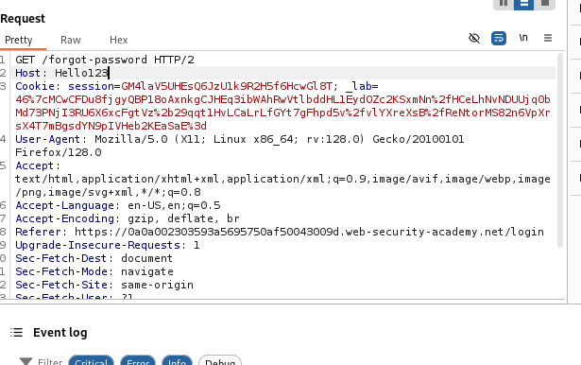

And Send The request again

It Show The request is accepted

Below in the image you can se that

HTTP/200 OK

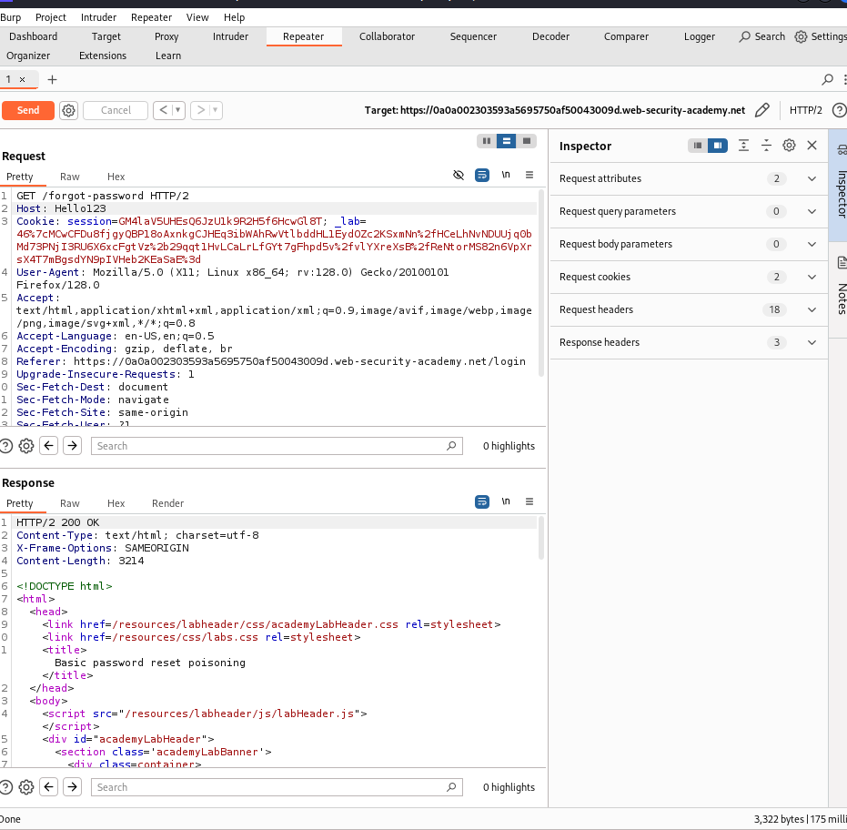

**Step:8**

Now We need to open our email client and refresh the browser window

You can see that our new one is created with Hello123

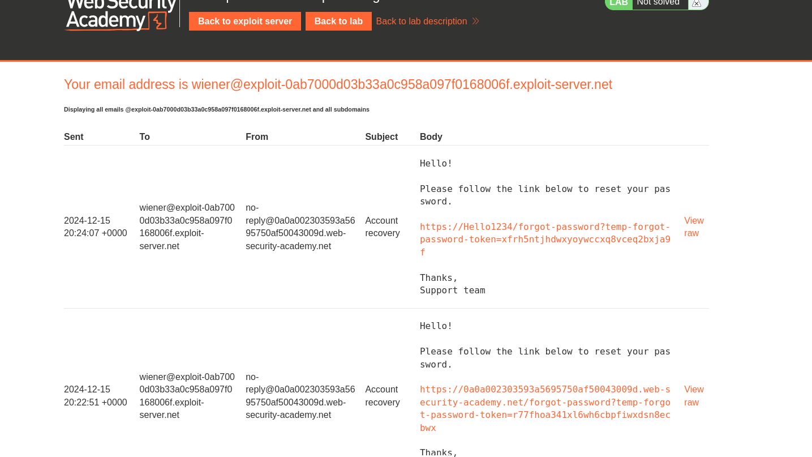

**Step:9**

Set a new Host header with the header of our exploit server,copy the link upto exploit-server.net leave front https also

See in image how i copied same as it is you da that thing only

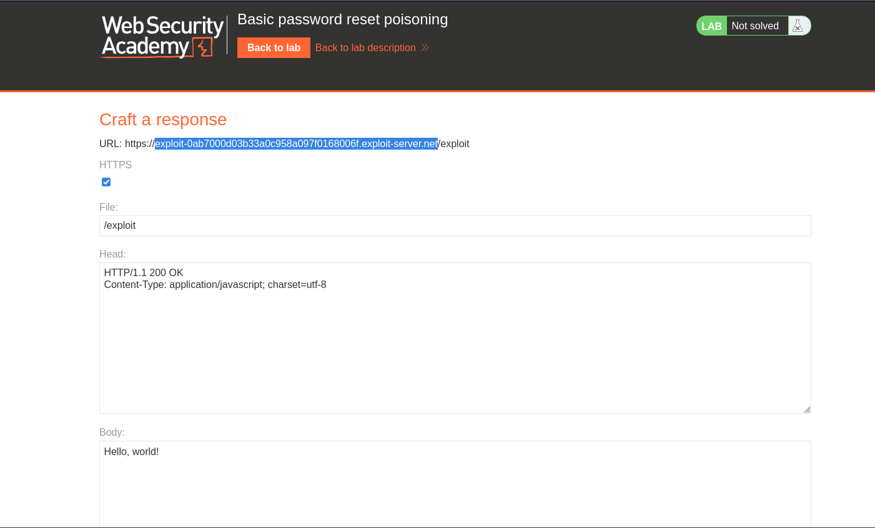Paste it on burp repeater in host and change the user name as u need

send the request again

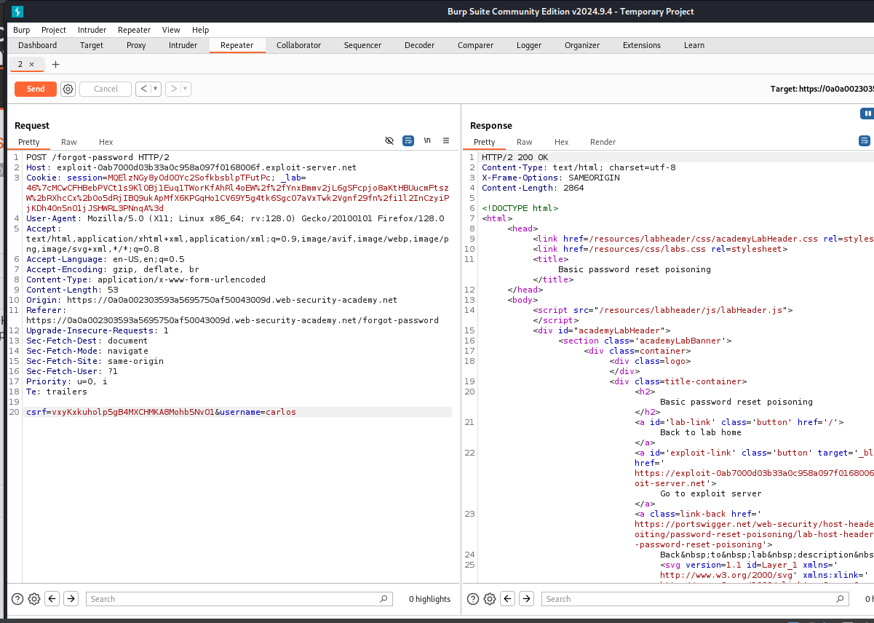

**Step:10**

Now go to access log

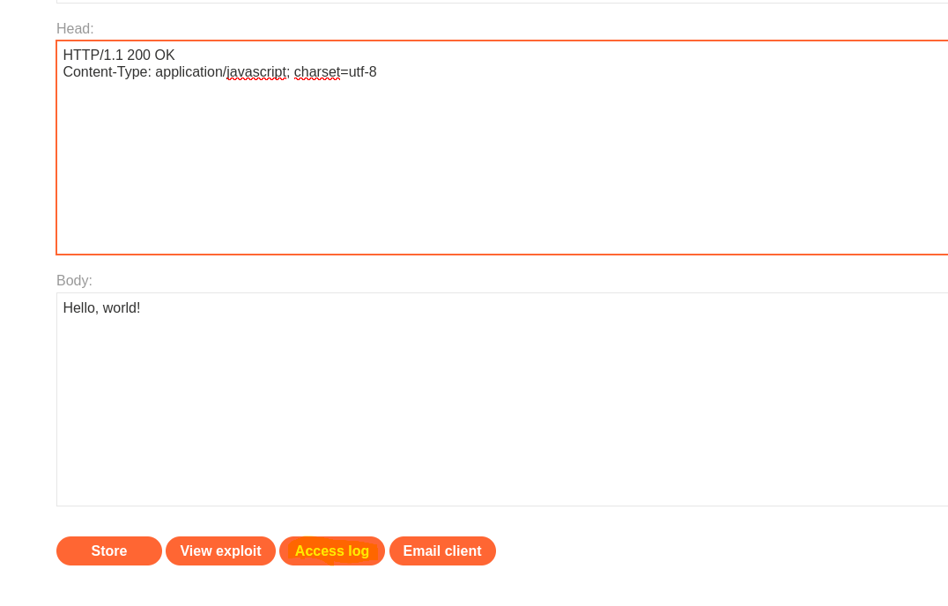

And there we need to look for get request from different ip address

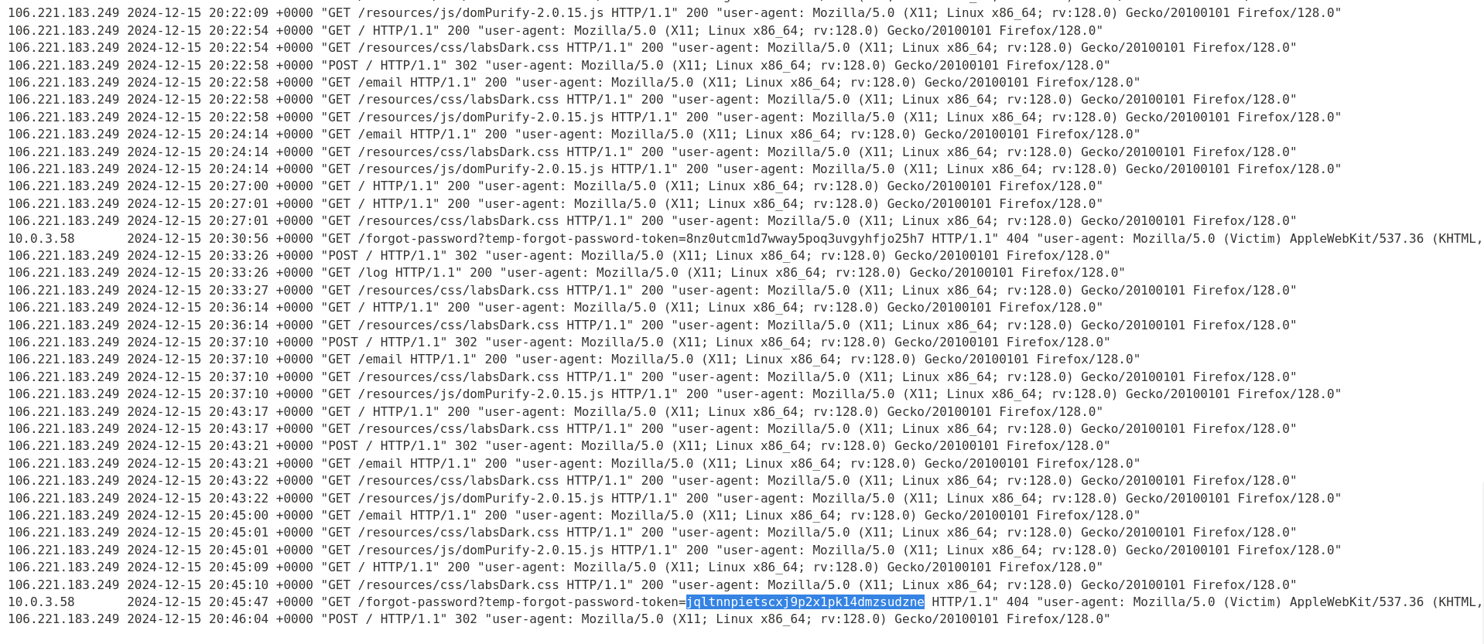

We got that see there in above pic

**Step:11**

Copy the new token and

Open a new tab and paste it on there

Back to our exploit server and open email client again

And now we need to use our address of first password reset address

The below image you see that you can chicken on that link its going to redirect another page shows invalid token

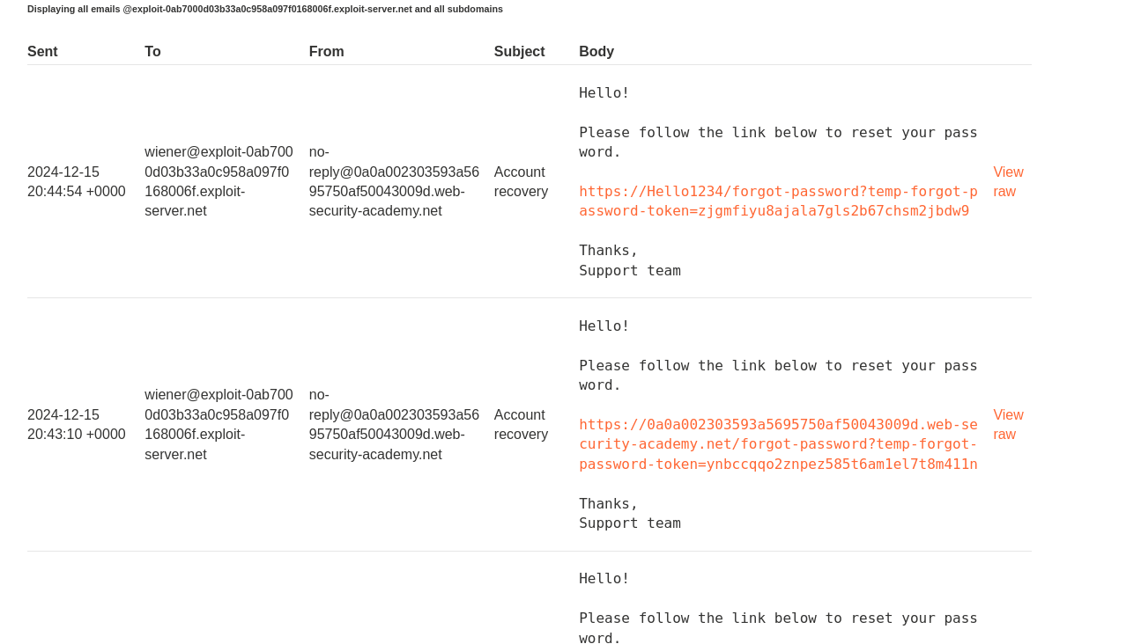

**Step:12**

After clicking that link Replace the marked token id with our previous we get on access log,refresh the page again,you will get a new interface to change the pasword for your new user. Click on submit.

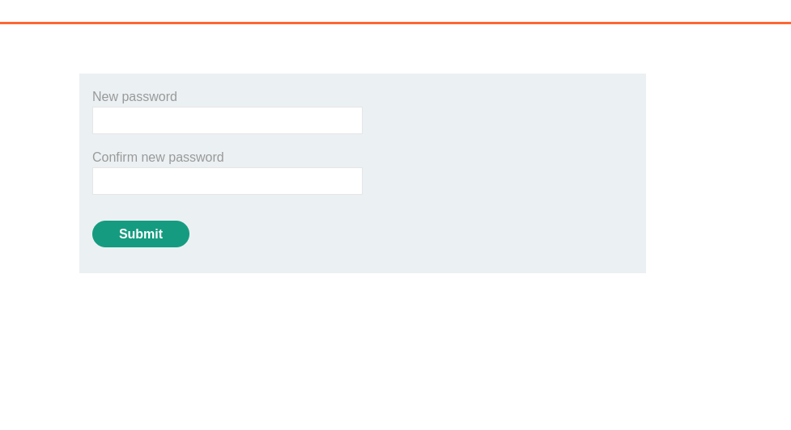

**Step:13**

And Now you go to login page and login with your new user id and password.

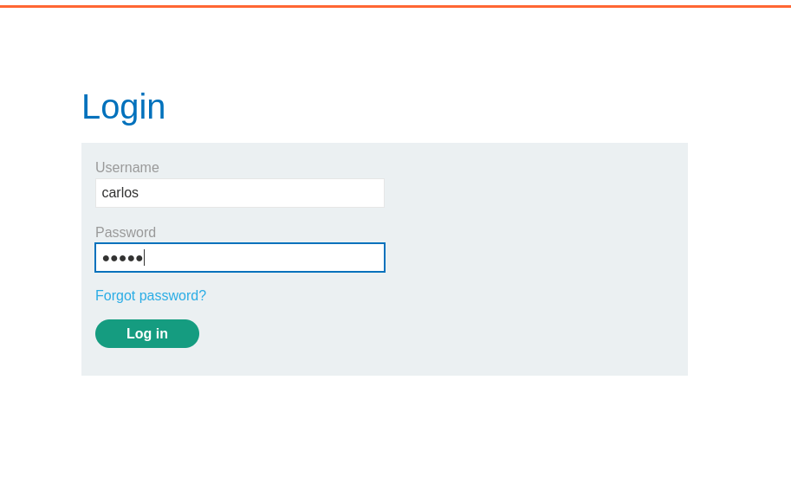

**Step:14**

And there you see that congratulations,you solved the lab

Thatsit with this lab you have solved it…

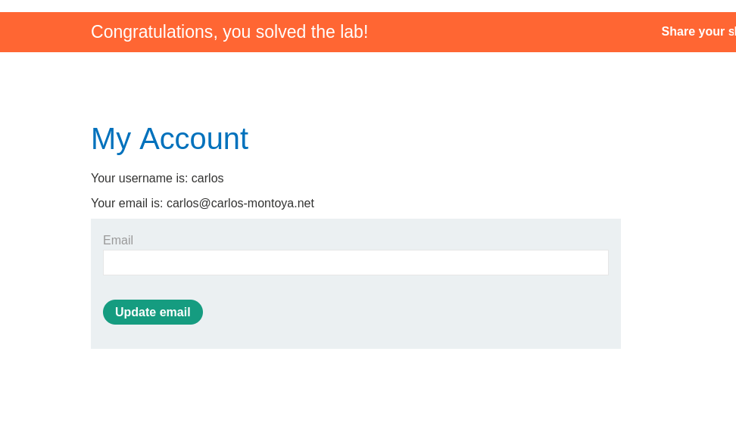

**Thankyou.**

# **2) Host header authentication bypass**

This lab makes an assumption about the privilege level of the user based on the HTTP Host header.

To solve the lab, access the admin panel and delete the user carlos

Solution:

**Step 1:**

First Acess the lab and and In The browser connect it to FOXYPROXY as burpsuite and NextGO to burp and check In http history search for

**Step 2:**

/Get request send it to repeator

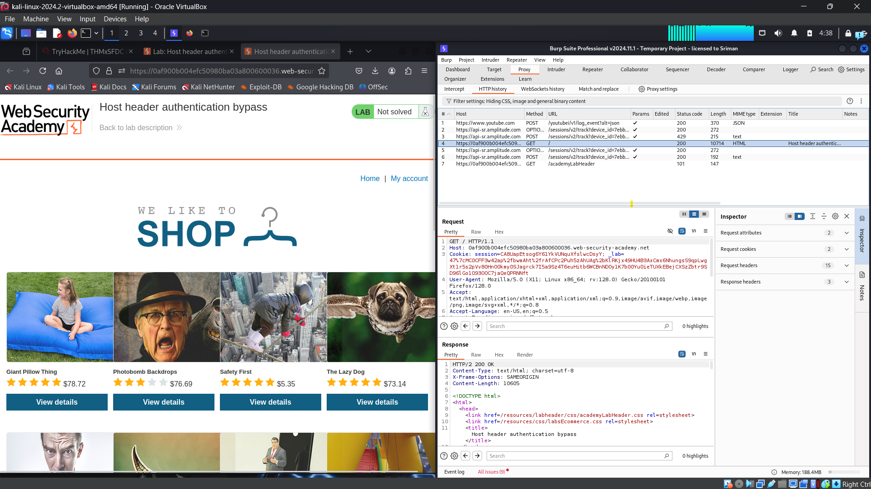

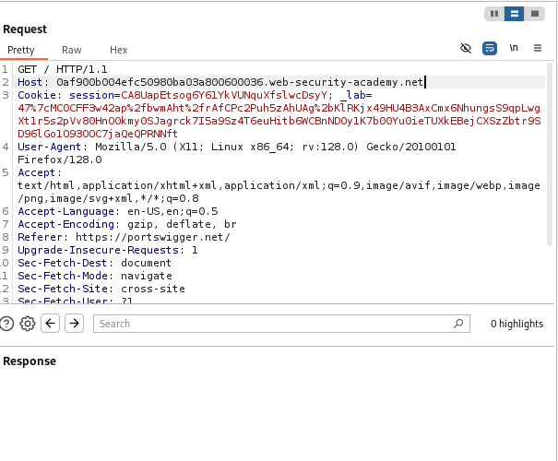

**Step 3:**

Change the host header domain .net to .com and send the request

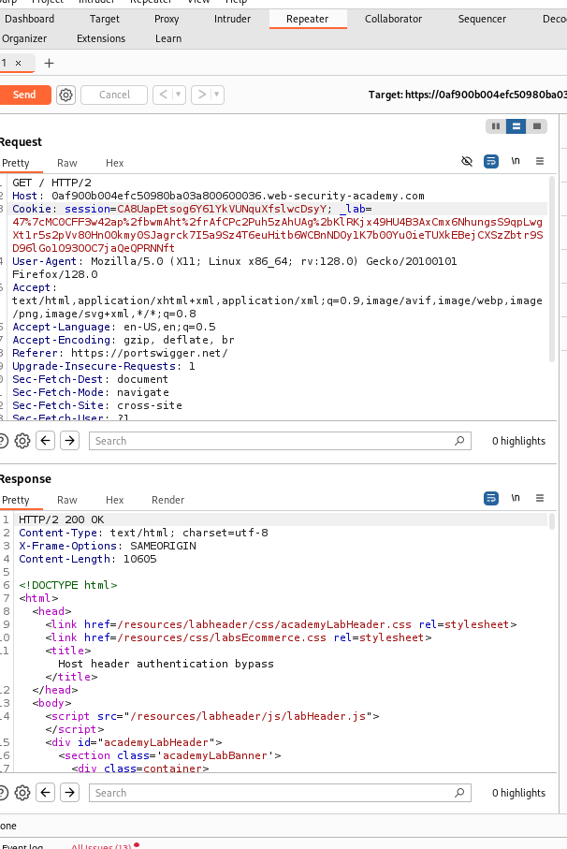

We get the response like this

**Step 4:**

In the URL add /robots.txt

What will do robots.txt file??

The **robots.txt** file is like a note to search engines, telling them which parts of a website they shouldn’t show in search results. For example, it might say:

“Don’t show the admin page at /admin.”

**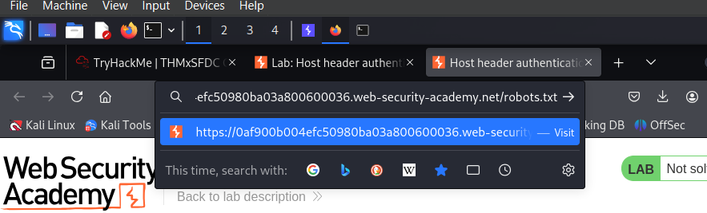  
In browser at last you add robots.txt  
  
  
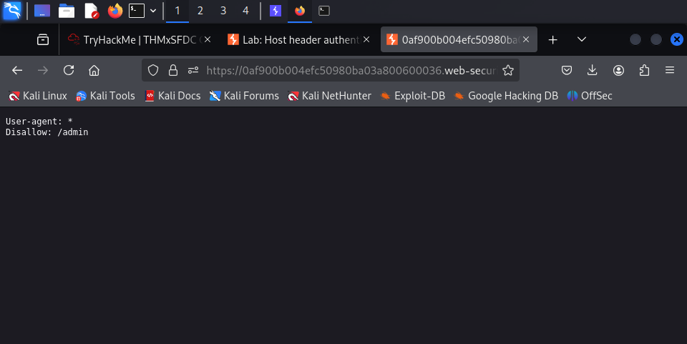**

We see there is a end point name as admin

**Step 5:**

Now we need to try to access the end point as admin lets see what will happen here

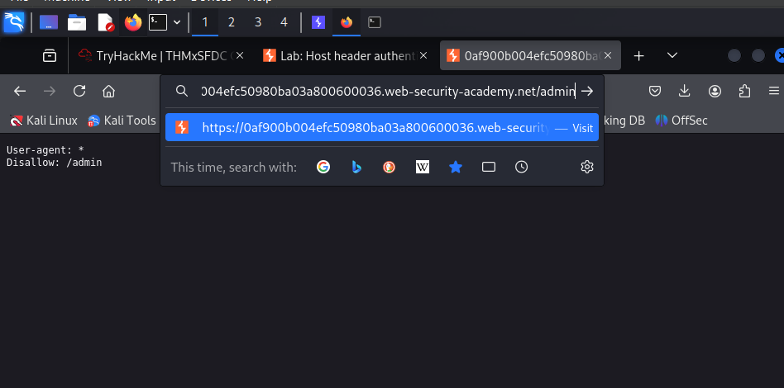

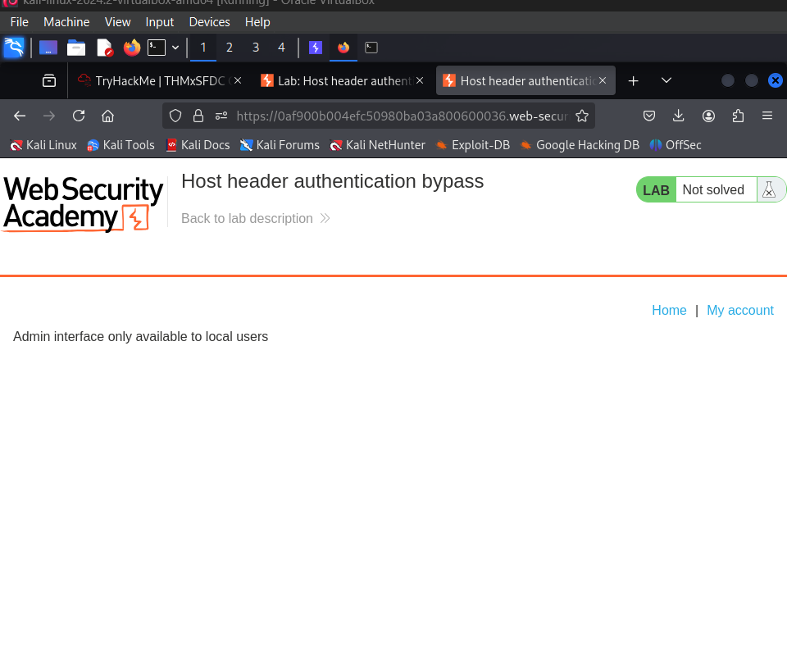

Here we can see that Admin interface only available to local user

**Step 6:**

So lets go to burp repeater and check in https history for /admin domain

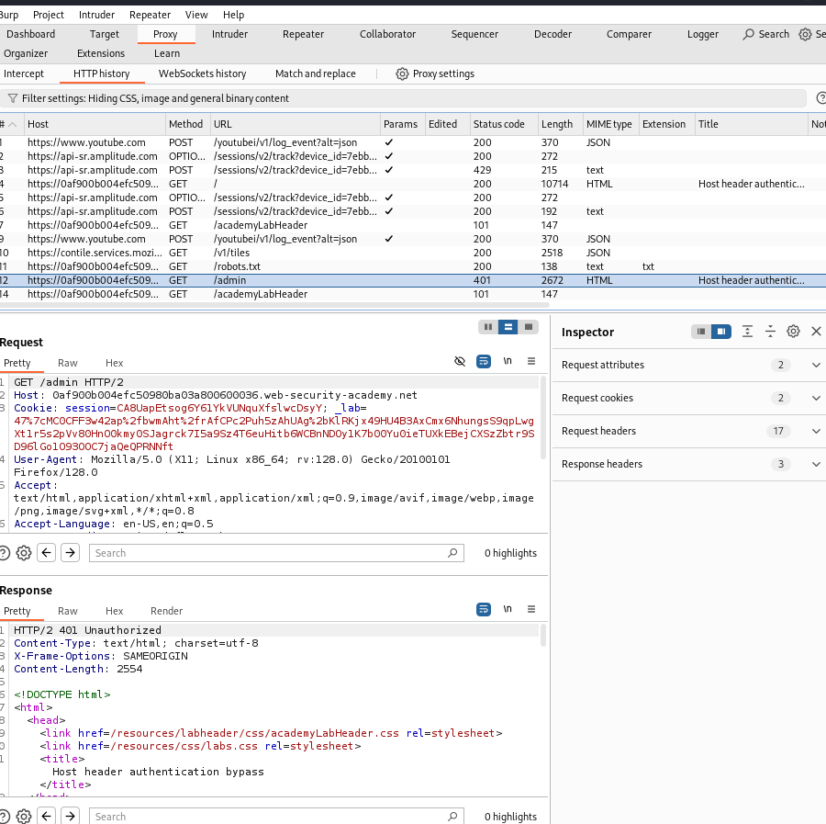

So there we get admin request  
  
**Step 7:**

And send that request to repeater

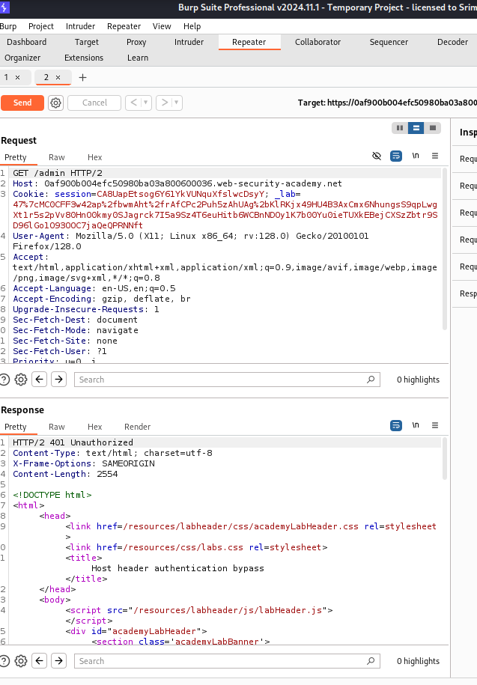

And again we send it to directly so that we get  **HTTP/2 401 Unauthorized**

**Step 8:**

Now we change the host header to **localhost** ans send the request again

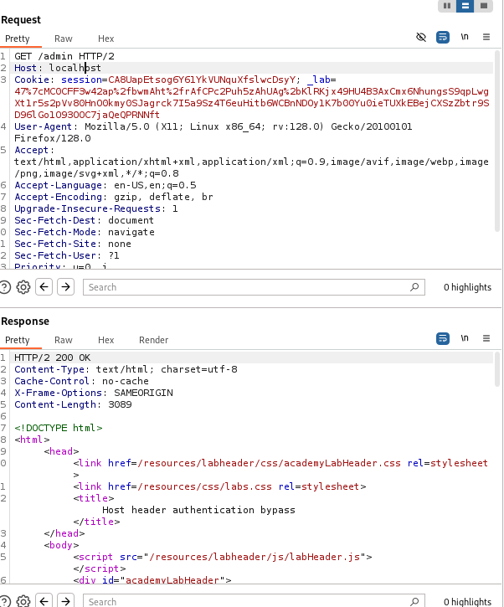

Here we get the response as ok

**Step 9:**

Add **Delete** command to the url and send the request again..

/delete?username=carlos

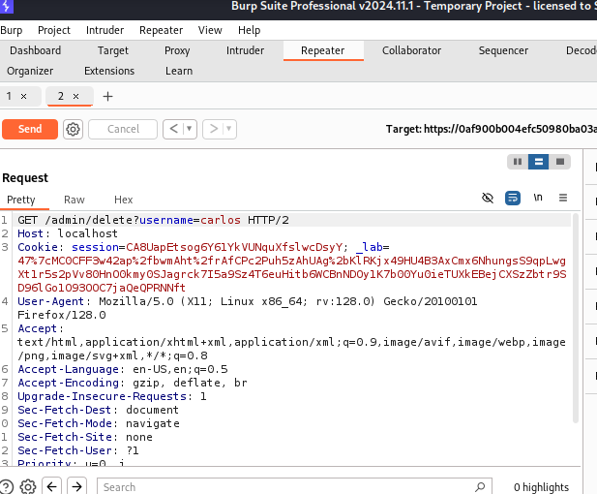

**Step 10:**

And There you can see our lab is solved

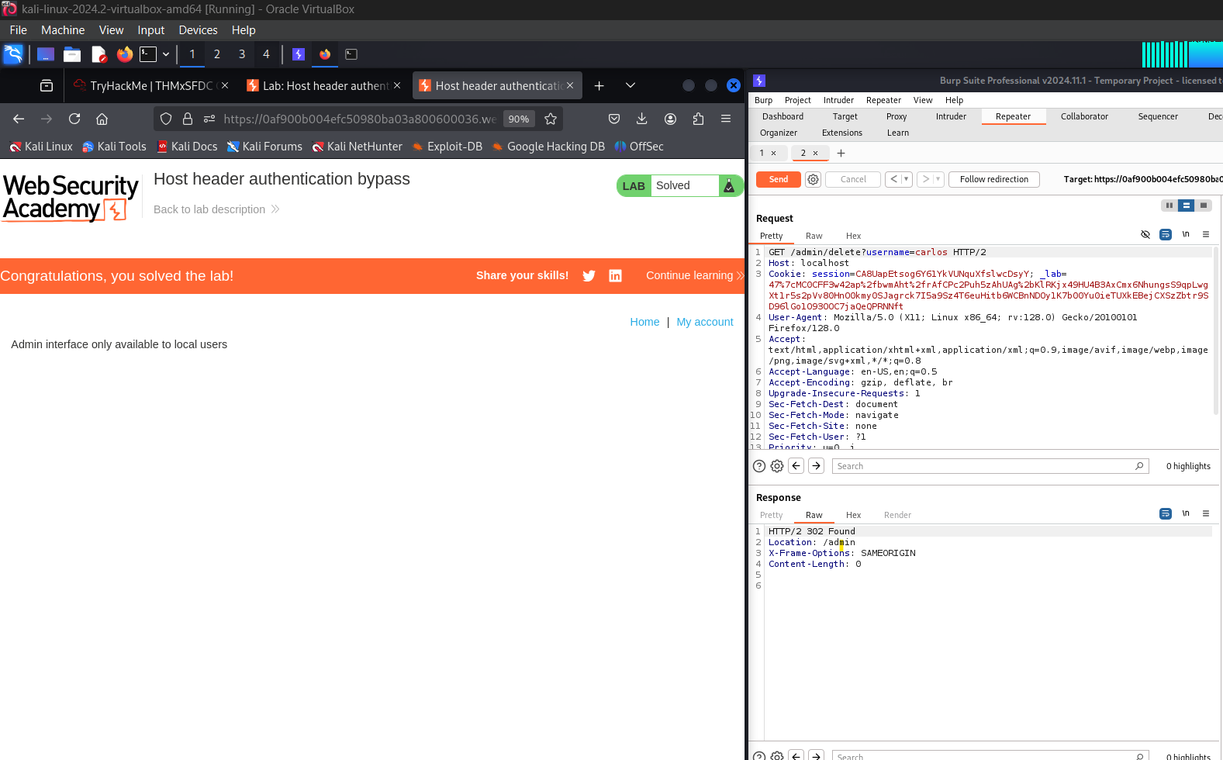

**Thankyou!**

# **3)Web cache poisoning via ambiguous requests**

This lab is vulnerable to web cache poisoning due to discrepancies in how the cache and the back-end application handle ambiguous requests. An unsuspecting user regularly visits the site's home page.

To solve the lab, poison the cache so the home page executes alert(document.cookie) in the victim's browser.

In simple way unnderstand the question

This lab has a vulnerability called **web cache poisoning**, which means you can trick the server into storing and serving malicious content to other users from its cache.

Here’s the situation in simple terms:

1. The website uses a **cache** to speed up loading times for users by saving a copy of frequently accessed pages (like the home page).
2. The server and cache handle requests slightly differently, creating a loophole.
3. You, as the attacker, can exploit this loophole to inject malicious code (like alert(document.cookie)) into the cached version of the home page.

When another user visits the home page, they’ll get the poisoned (malicious) version from the cache. This causes the user's browser to run your malicious code, like showing an alert with their cookies.

Your goal is to exploit this behavior to poison the cache and make the victim's browser execute your code.

**Solution:**

**Step 1:**

Connect to foxyproxy Burp in browser and Access the lab

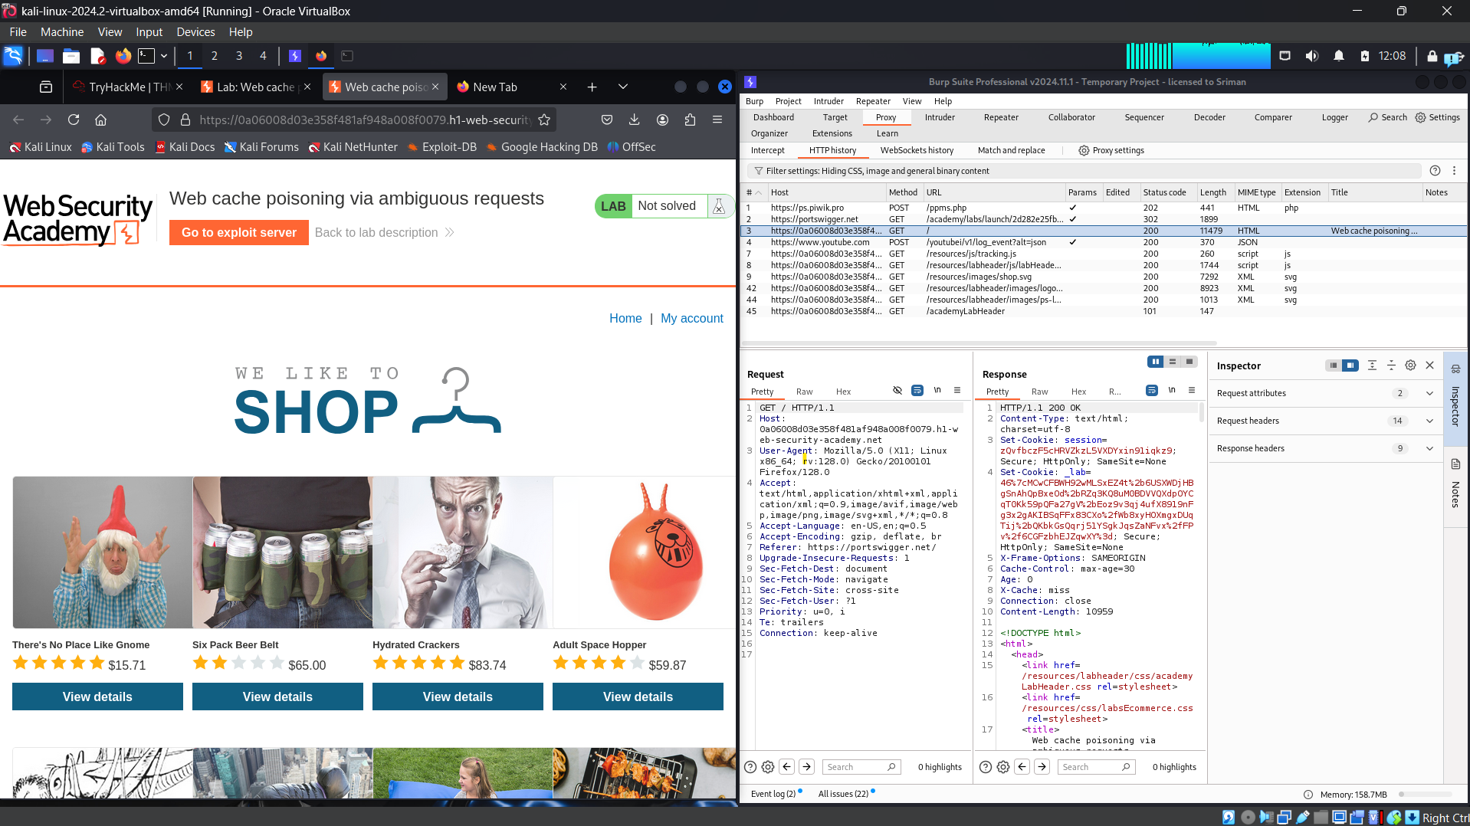

Go to burp and search for https get request and send it to repeater

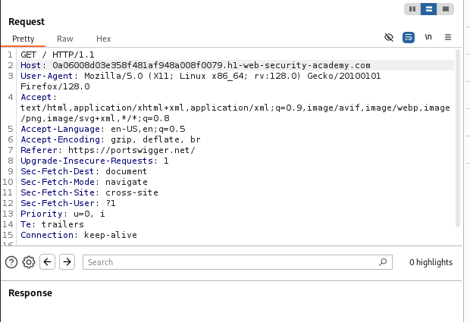

**Step 2:**

Change the host heade we get as .net to .com send the request

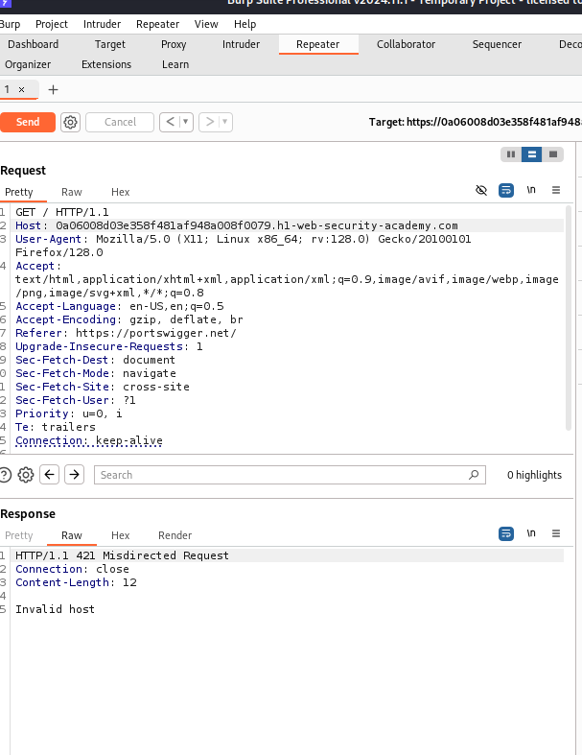  
  
We get it as a invalid host..

**Step 3:** So again next go to proxy and check HTTP History get response

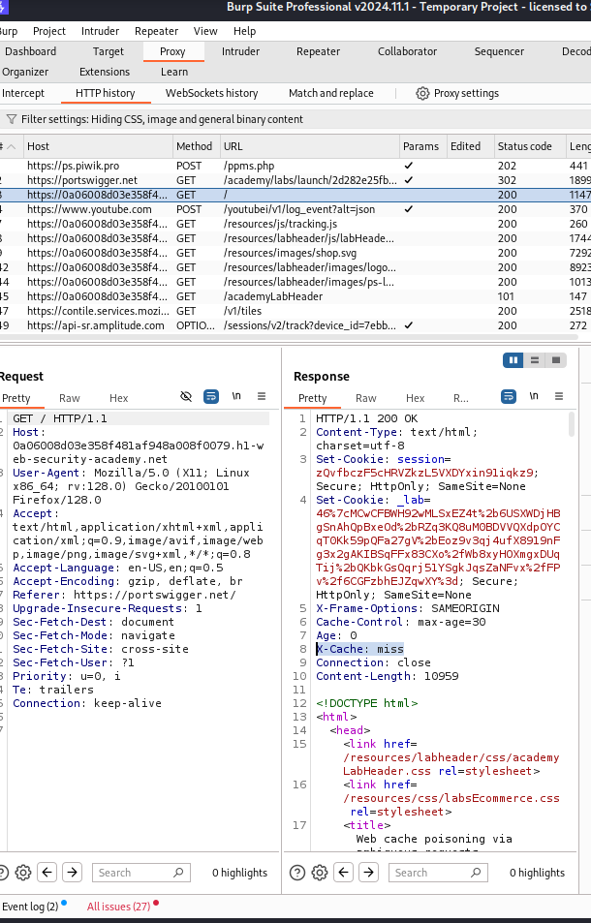

There we see that in the response X-CACHE:MISS

**Step 4:**

Come back to the burp repeater and enter in the url as /?cb=hacker

cb-Cache busting is a technique used by web developers to force the browser to load the most recent version of a file, rather than a previously cached version. When a static file gets cached it can be stored for very long periods of time before it ends up expiring. This can be an annoyance in the event that you make an update to a site however, since the cached version of the file is stored in your visitors' browsers, they may be unable to see the changes made. This is due to the fact that a visitor's browser will locally store a cached copy of your static assets given that your website is configured to [leverage browser caching](https://www.keycdn.com/support/leverage-browser-caching).

And there in below you see that x-cache is still miss

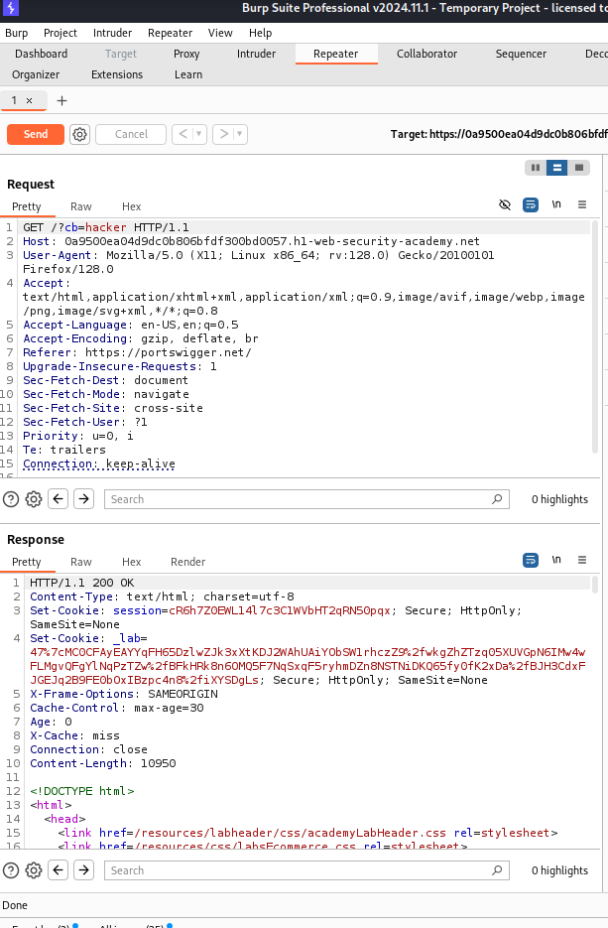

Once again send the request(send multiple requests until u get xcache as hit)

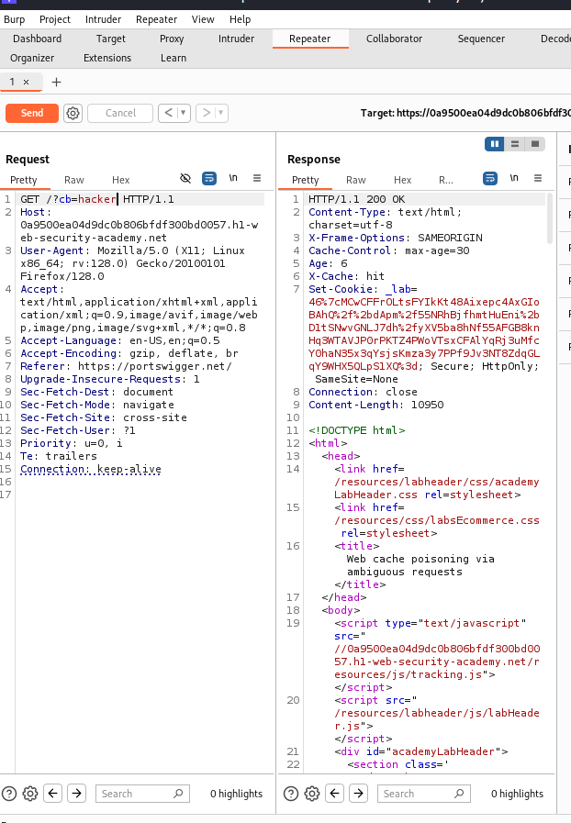

In response you can see that X-cache:hit

Step 5:

Add the second host as abcd1234

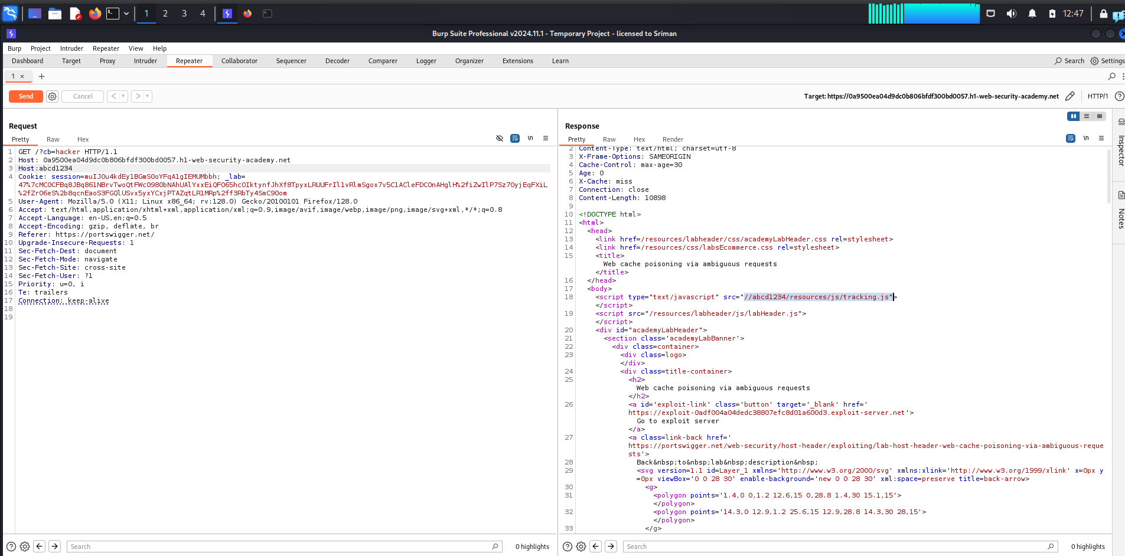

So there we get a response as src=”//abcd1234/resources/js/tracking.js”

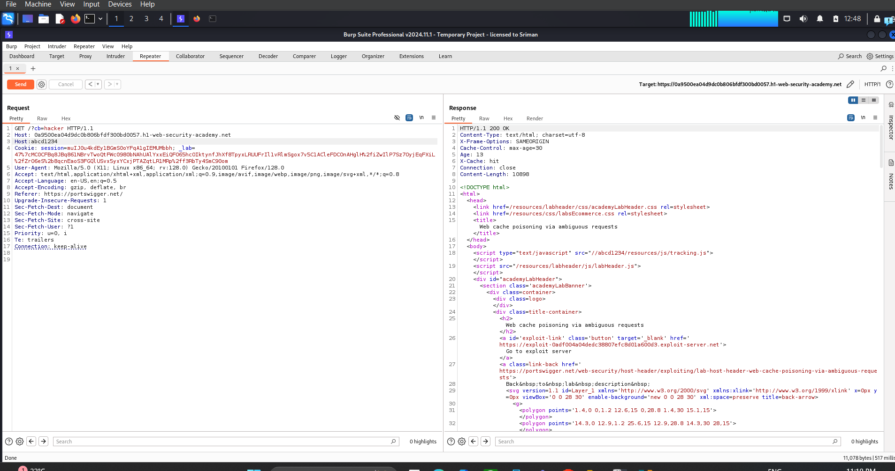

the difference (hit)

**Step 6:**

Now delete the second host and send the request again  
There we can see still received the value of the second host header

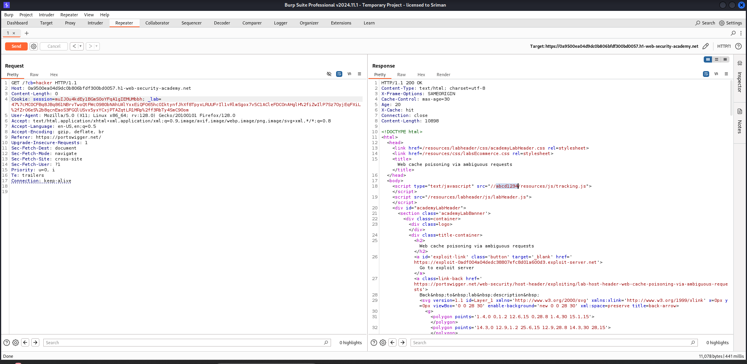

**Step 7:**

Go to the exploit server in the portswigger lab and create a file as

/resources/js/tracking.js

In body create an alert as alert(document.cookie)

Store that it means need to save that

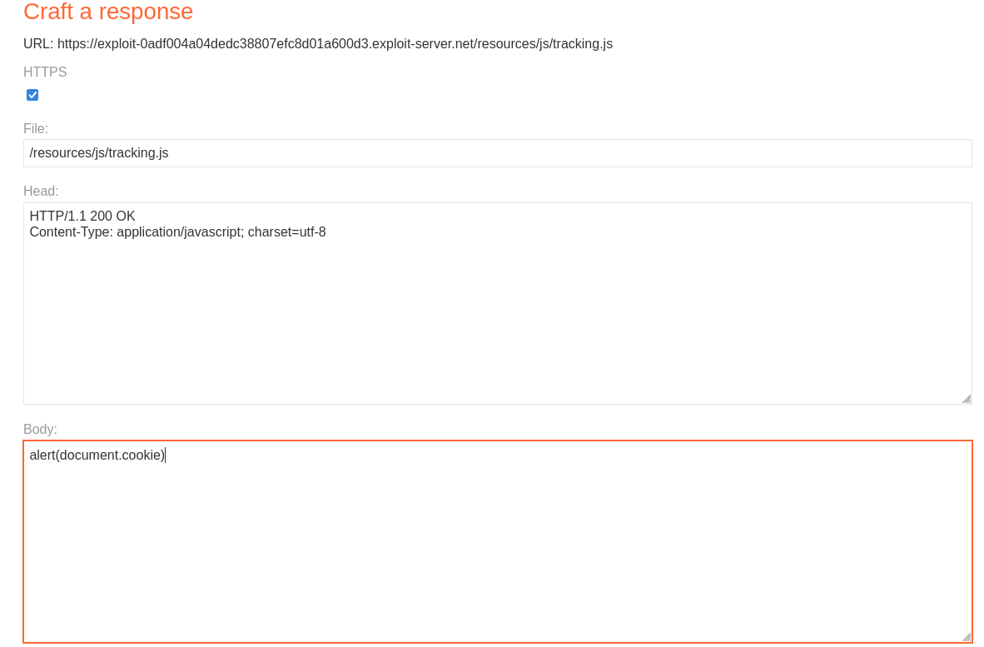

**Step 8:**

Back to burp repeater And remove that /?cb=hacker in URL and **Second host:exploit-0adf004a04dedc38807efc8d01a600d3.exploit-server.net**We get that link on exploit server what you get just copy paste it

Send the request So there you see

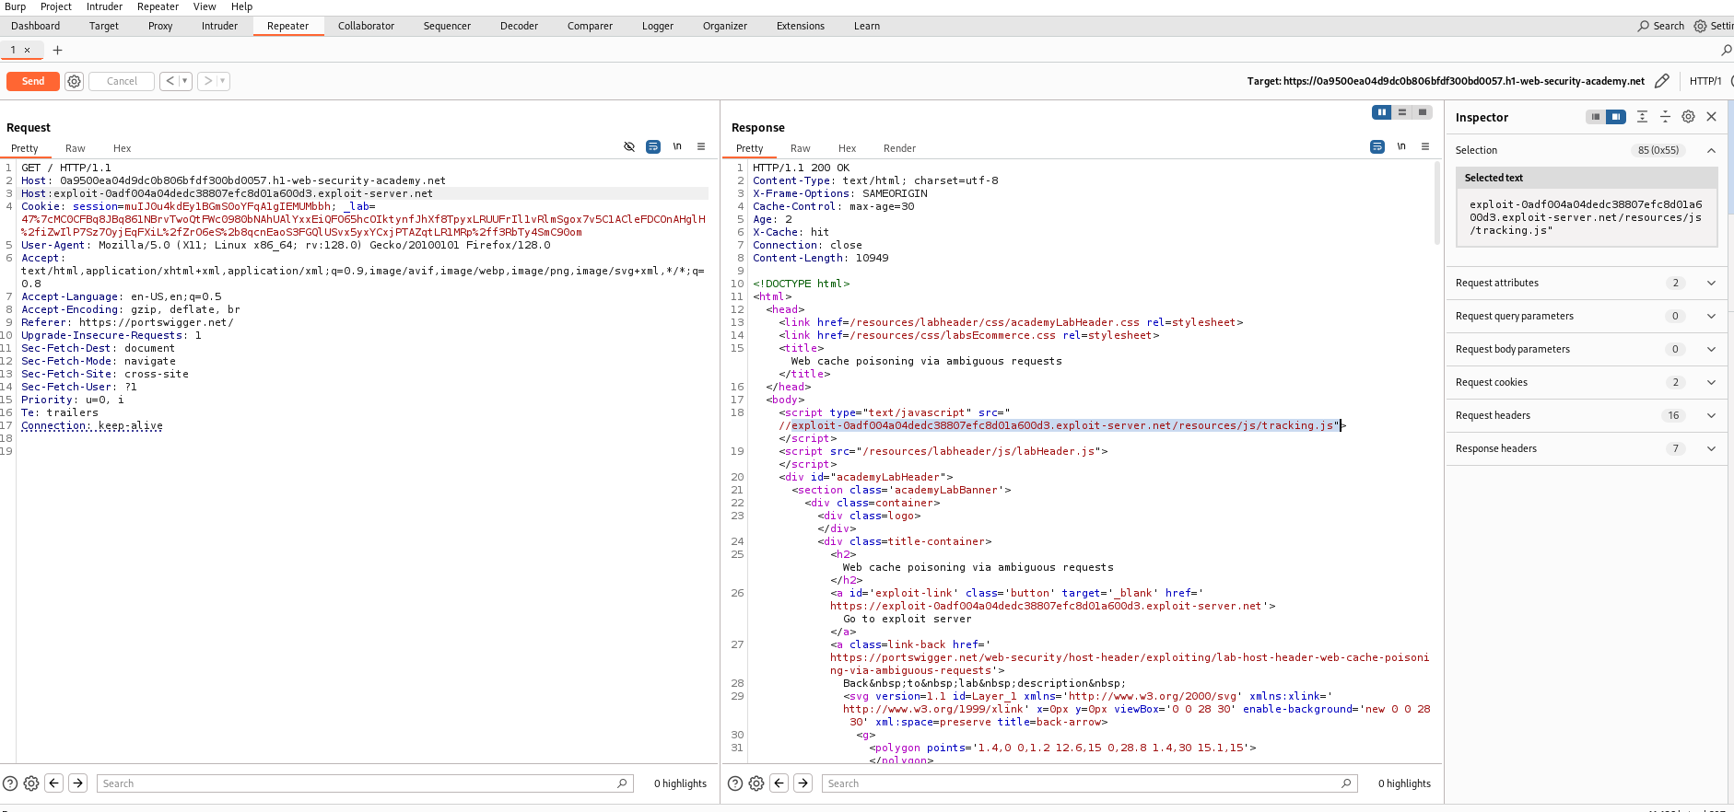

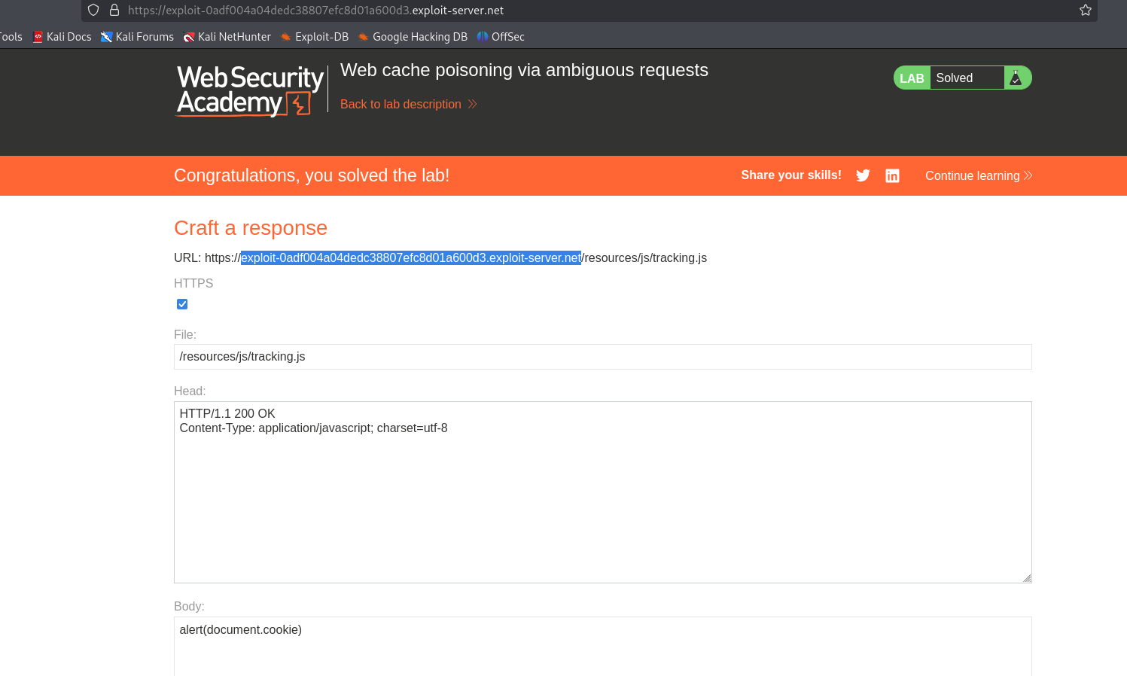

Our lab was solved Thankyou!!

# **4)Routing-based SSRF**

This lab is vulnerable to routing-based SSRF via the Host header. You can exploit this to access an insecure intranet admin panel located on an internal IP address.

To solve the lab, access the internal admin panel located in the 192.168.0.0/24 range, then delete the user carlos.

**Solution-**

**Routing-based SSRF (Server-Side Request Forgery)** happens when an attacker tricks a server into making unauthorized requests to internal or restricted systems by exploiting how the server handles routing or redirection.

Here’s the concept in simple terms:

1. The vulnerable server accepts user input (like a URL) to make requests to other servers.
2. Instead of requesting a legitimate external resource, the attacker gives a URL that points to an internal system (like http://localhost/admin or http://127.0.0.1).
3. The vulnerable server processes this input and unknowingly sends a request to the internal system, allowing the attacker to:
   * Access restricted data.
   * Perform unauthorized actions within the internal network.

In **routing-based SSRF**, the vulnerability specifically arises because of how the server resolves or redirects requests based on routing rules. For example:

* An attacker might bypass restrictions by using alternative routing methods (e.g., using IP addresses, subdomains, or encoded URLs).

The attacker uses these tricks to make the server send requests to places it shouldn't, potentially exposing sensitive information or performing unauthorized actions.

So now come to practical lab  
  
Lets solve the lab

**Step 1:**

Connect the foxy proxy to burp and access the lab so next go to burp http history and search for get request so there you can see that send it to repeater

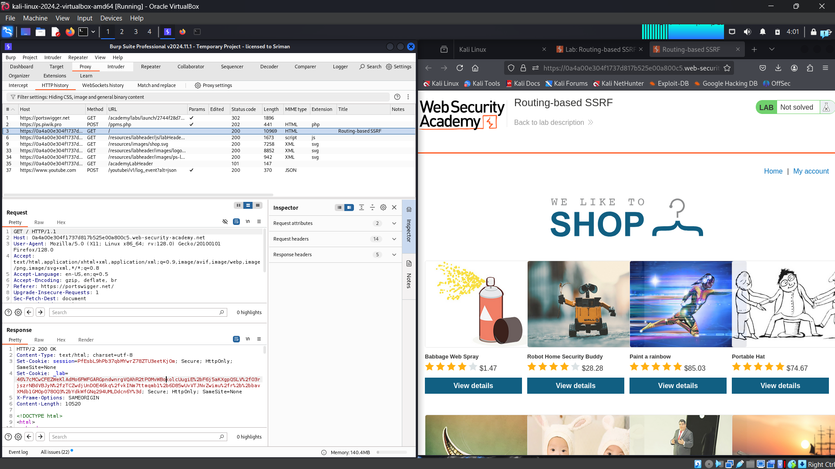

After that open burp open collaborator client

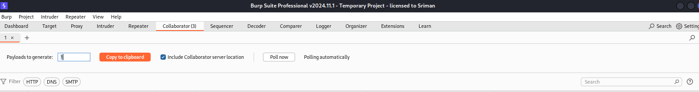

**Step 2:**

Click on copy to clipboard and next move to repeater and replace the host name with the copied one and send request

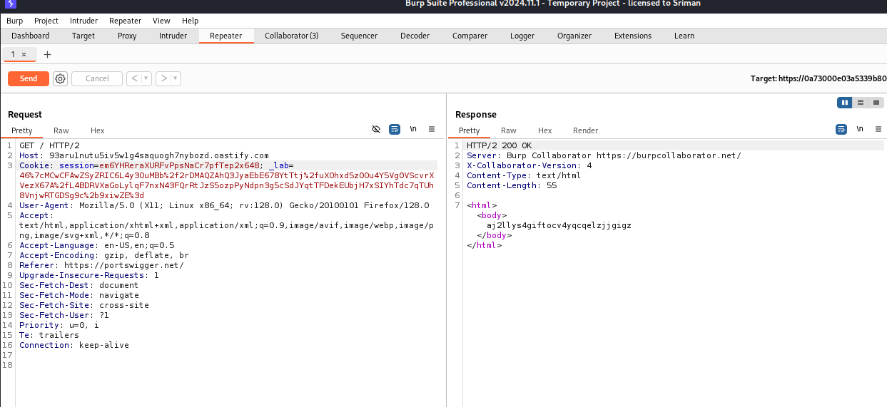

So here we get a HTTP/200OK response next what we wanna do means

**Step 3:**

Switch to collaborater and see there we get some packets and in that we get one http packet request also see in the below image

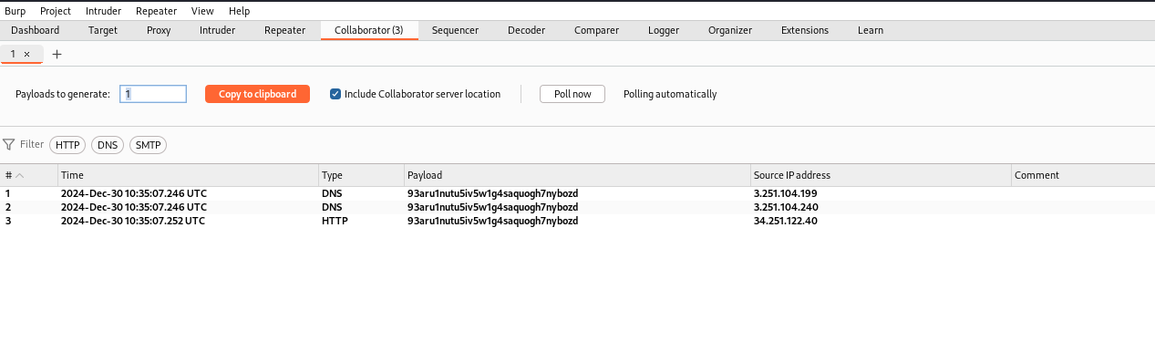

So that http packet confirms that we can do an attack with it.. Means its have some vulnerability so that we need to exploit the vulnerability

**Step 4:**  
So now close the collaborator and switch to the burp proxy next open http history and search for get request

Send that get request to intruder

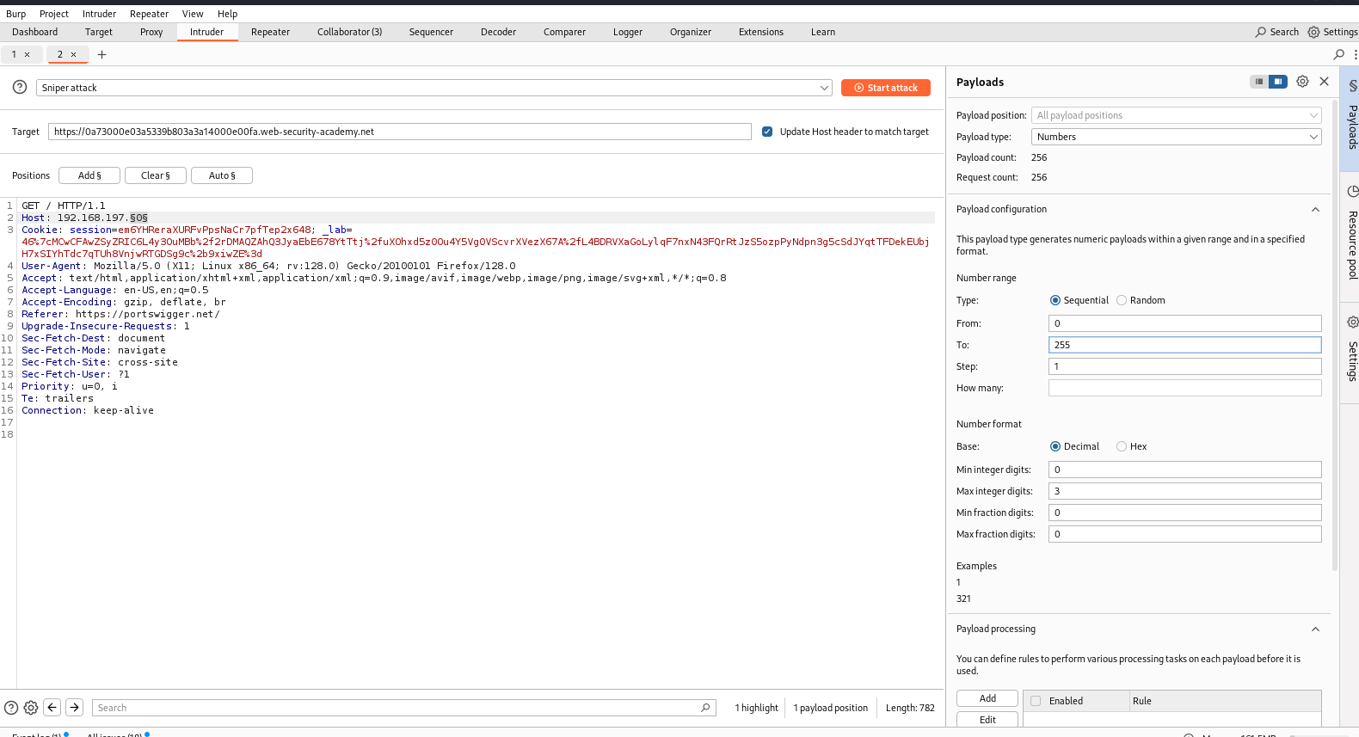  
After sending it to intrude clear each and every position and  
In host add your ip address(which is given in the lab) at the end of the ip address add exception

**Step 5:**

Next go to payloads and  
Set payload type as number  
Payload configuration as 0 to 255 steps as 1

And start the attack

**Note:remove the tick box at update host header to target**When you remove the tick box at that time only the attack is going to work properly  
(meanwhile when im doing i didnt get properly so dont to that kind of silly mistakes here…)

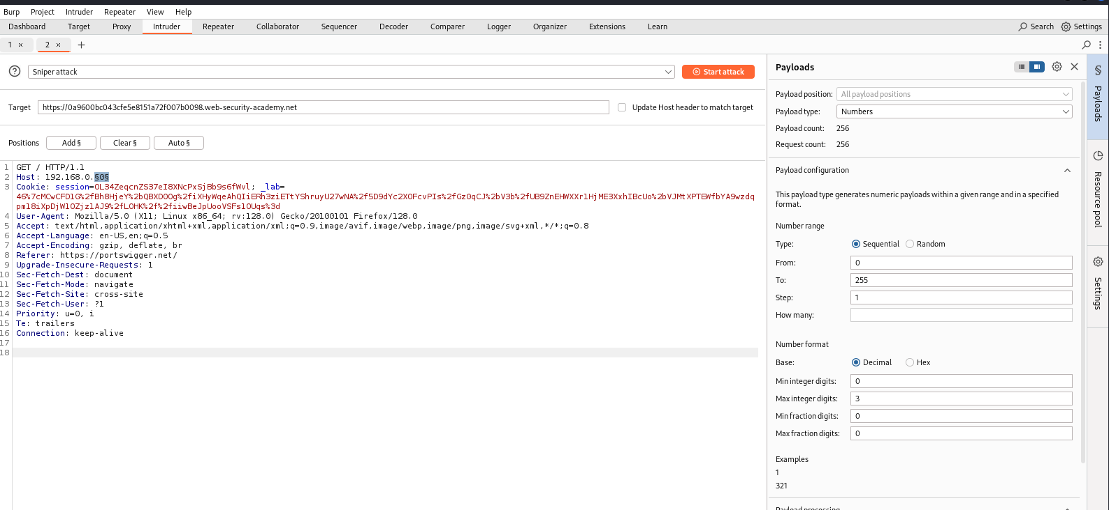

**Step 6:**

Lets start the atack so there we get

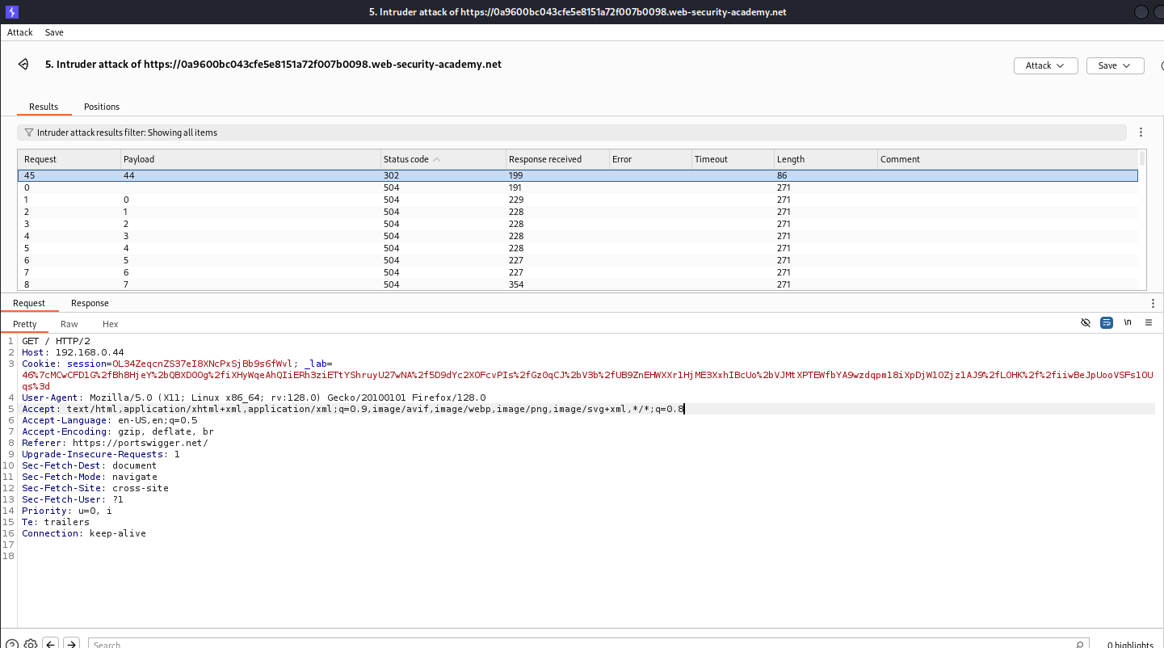

At status code 302 we find our ip address where the admin login panel is there we get that address

**Step 7:**

Send this request to repeater after that again send a request we get response like below shown

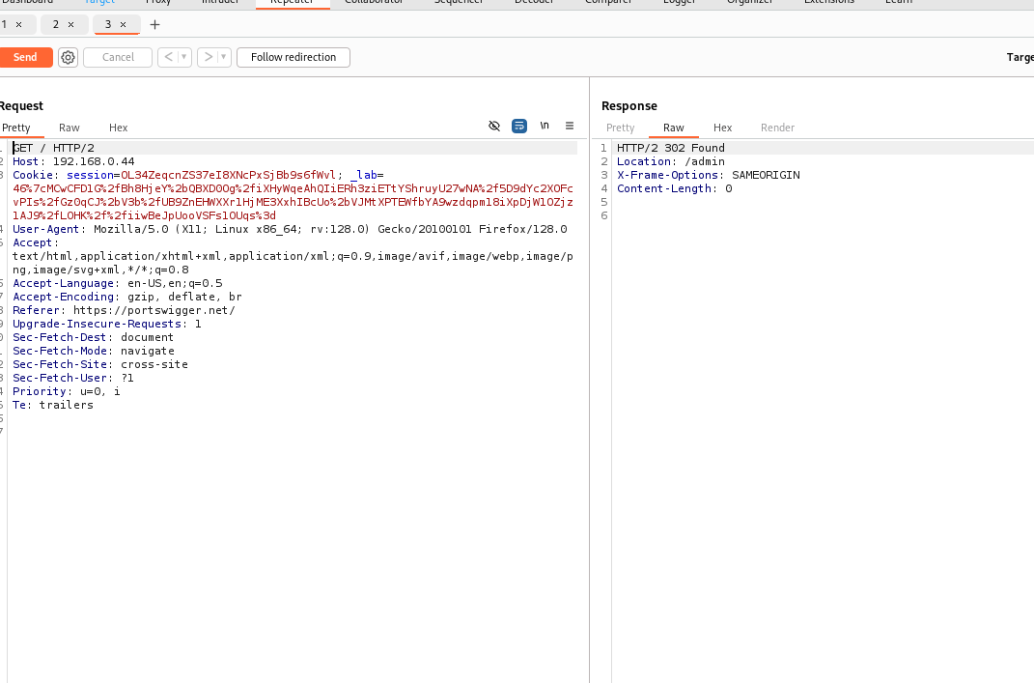

**Step 8:**

Add admin to url and send the request

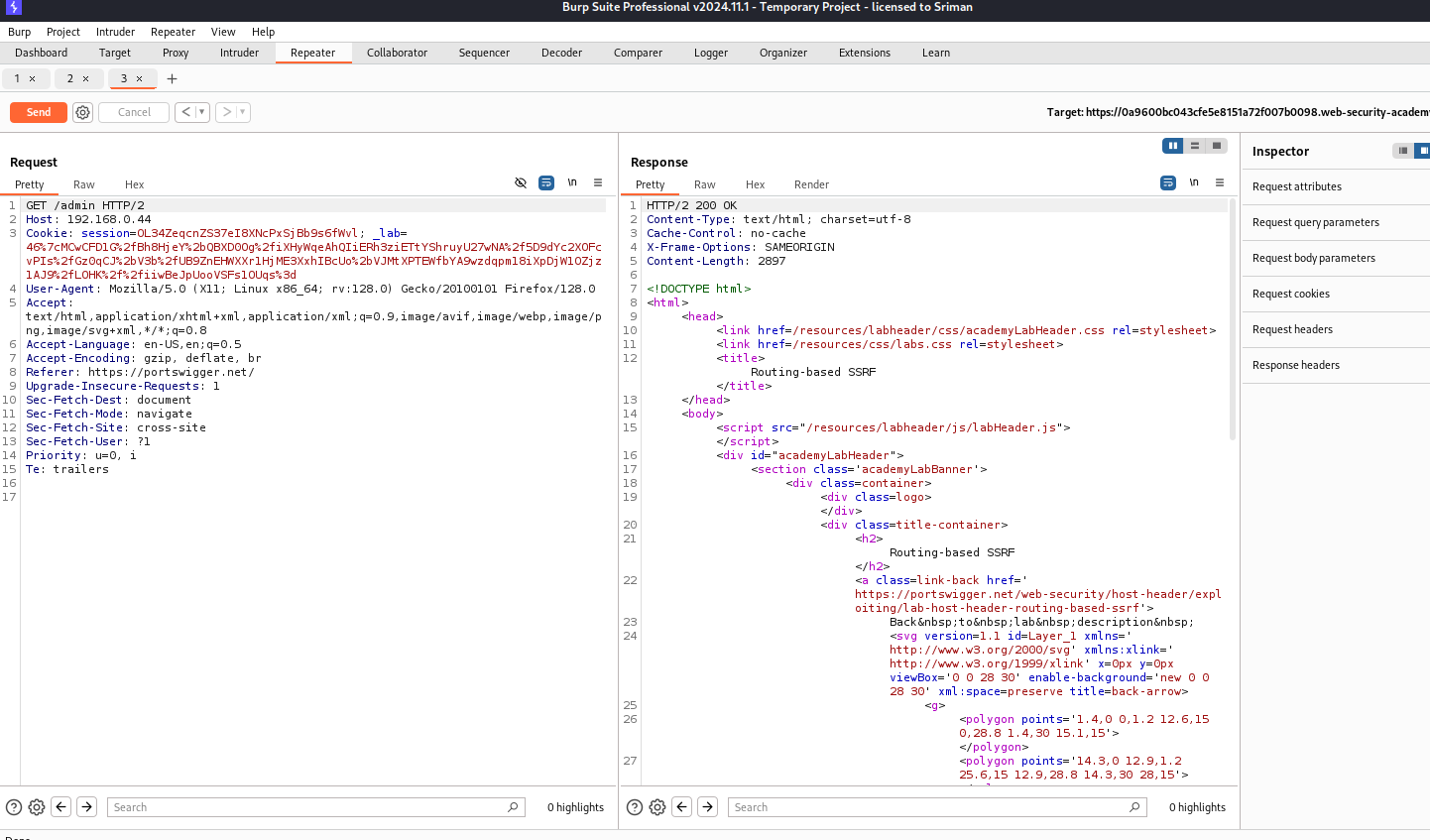

So here we got a pretty good response so that we can access to the admin panel

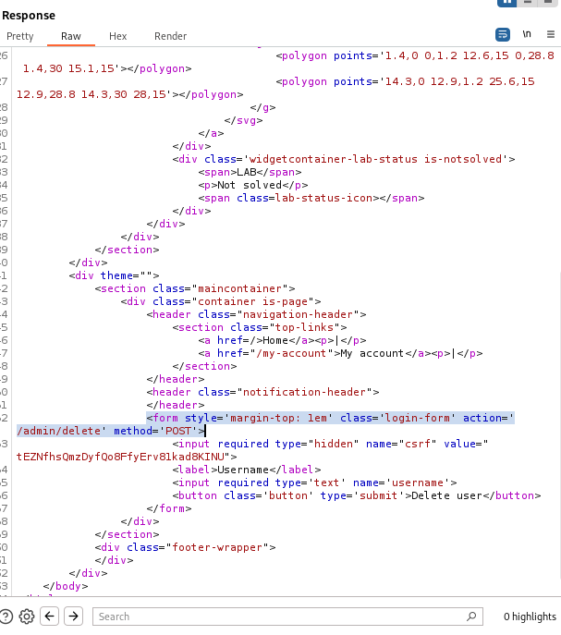

In the admin/delete you can see that Csrf Token you need to copy that token

**Step 9:**

Now move to repeater  
And At Last in the url after Get Add this

**/admin/delete?csrf=<urs csrf token value> & username=carlos**  
  
Then send the request again and there you see your lab was solved

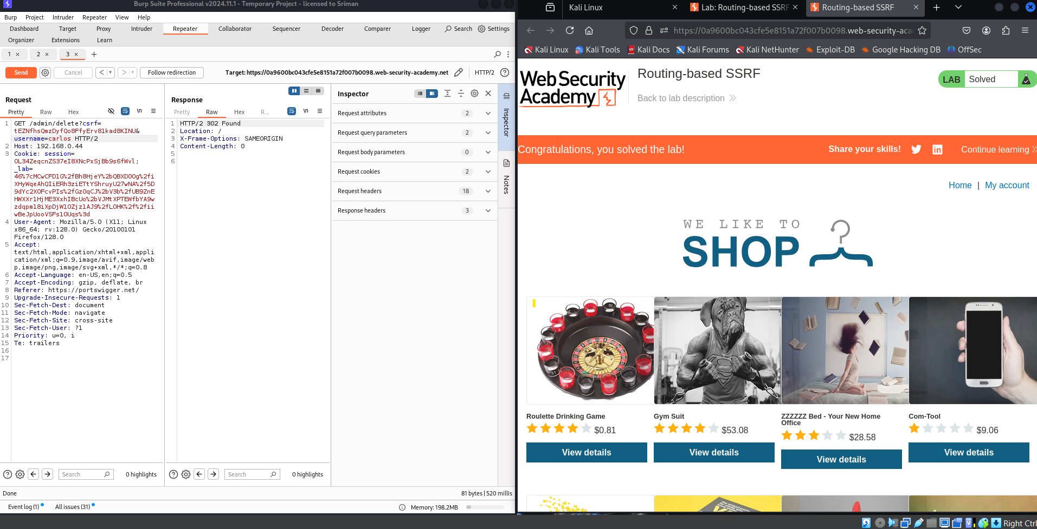

Thankyou!!

# **5)SSRF via flawed request parsing**

This lab is vulnerable to routing-based SSRF due to its flawed parsing of the request's intended host. You can exploit this to access an insecure intranet admin panel located at an internal IP address.

To solve the lab, access the internal admin panel located in the 192.168.0.0/24 range, then delete the user carlos.

SOLUTION:

Imagine a website fetches images from a URL you provide. If the server checks the URL poorly, an attacker can trick it by sending something like:

http://trusted.com@evil.com

The server thinks it's fetching from trusted.com, but actually, it fetches from evil.com. This allows the attacker to access sensitive data or internal systems by exploiting how the server misreads the URL.

The lab looks like similar to the routing-based SSRF only but some minor changes will be there like we need to change some portions in get url so let solve this

**Step 1:**

As it is connect foxyproxy to burp and move to burp proxy and then go to http history and search for get request and send that to Burp repeater

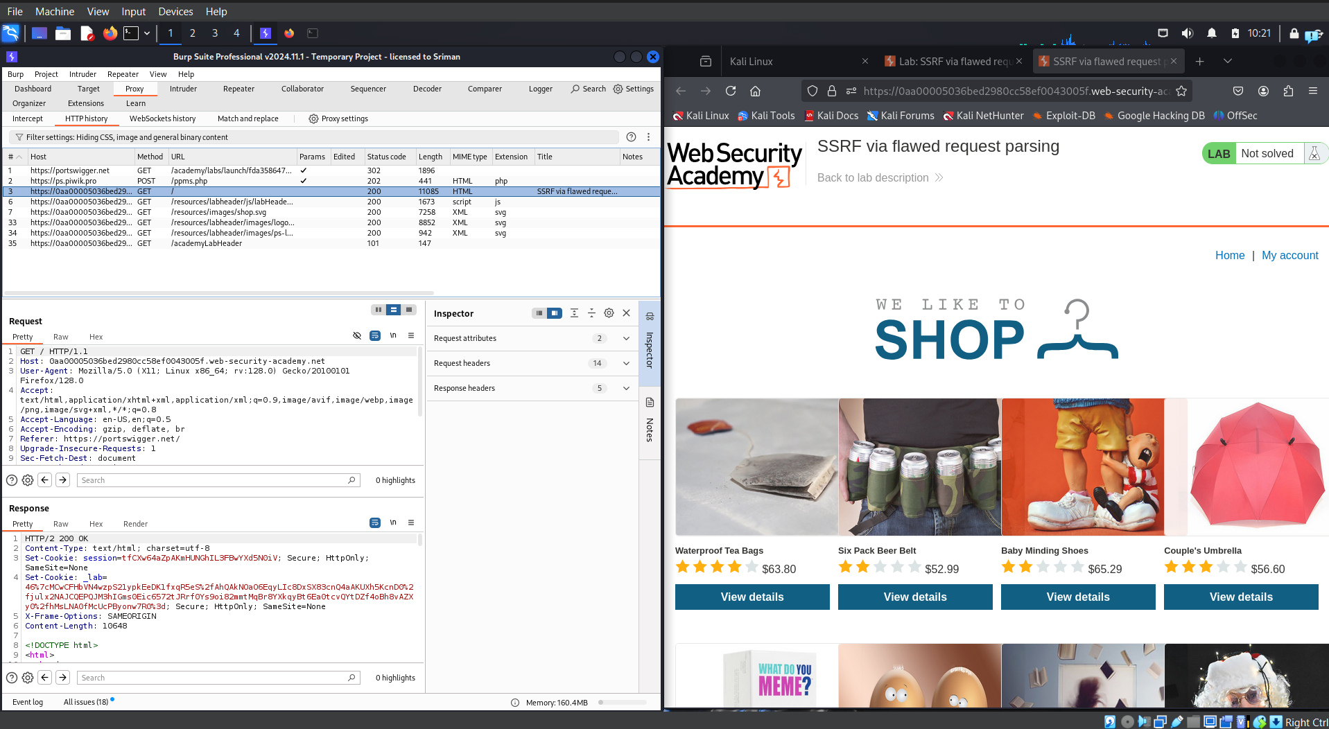

**Step 2:**

Change the host .net to .com and send the request it shows error it means host error is there so..

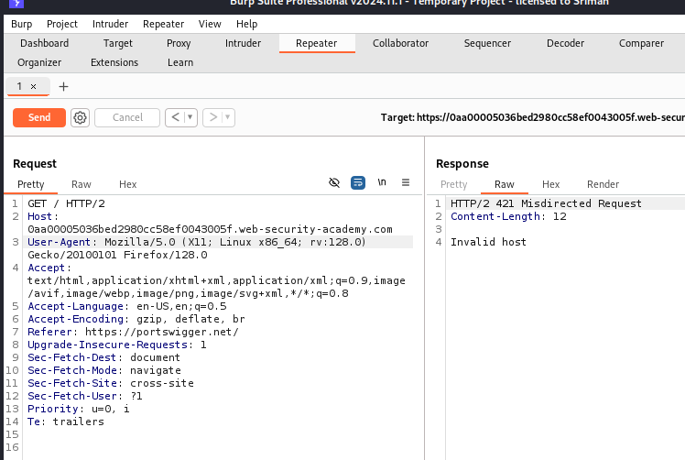

**Step 3:**

Now we try to use our absolute url in the get request(which get to us at access lab near so copy that url)   
  
The domain of the hos header is different from the original

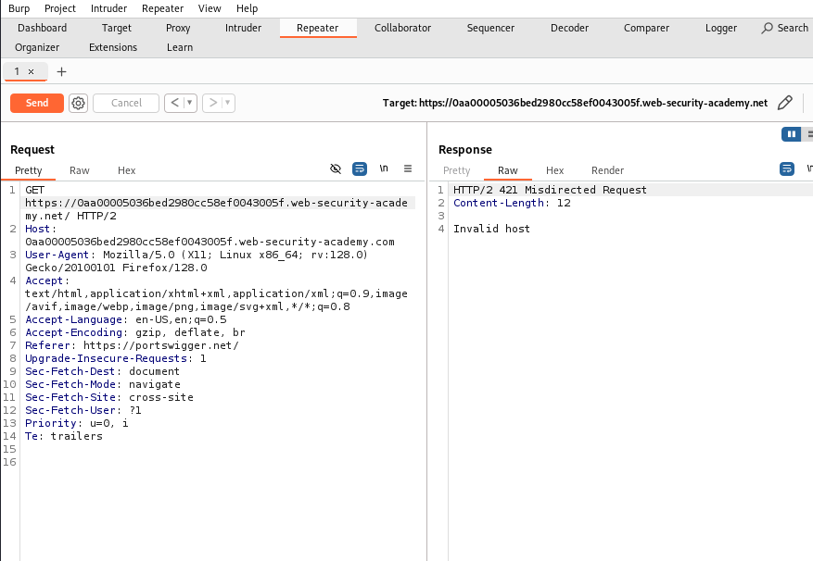

**Step 4:**

Now we use the burp collaborator client

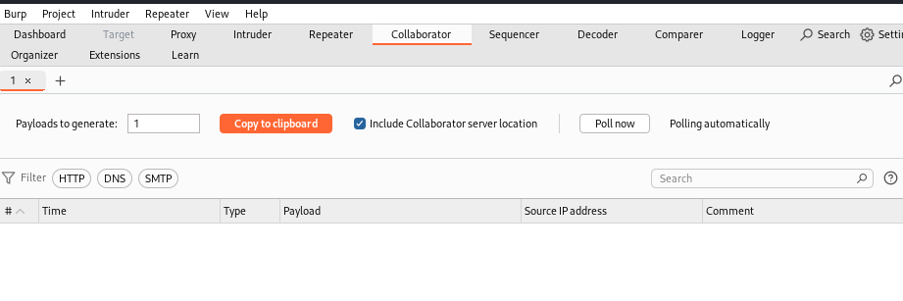

Copy to clipboard and replace the **host** with pasting it and send the request

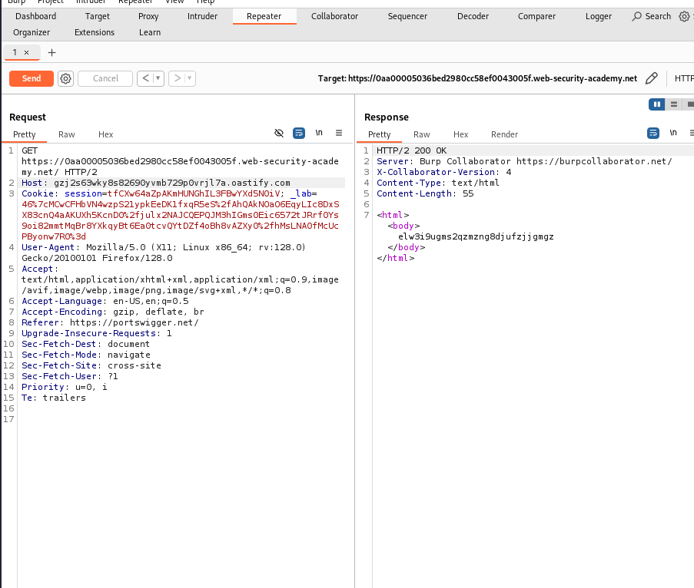

**Step 5:**

Now go to collobaroter and check for packets

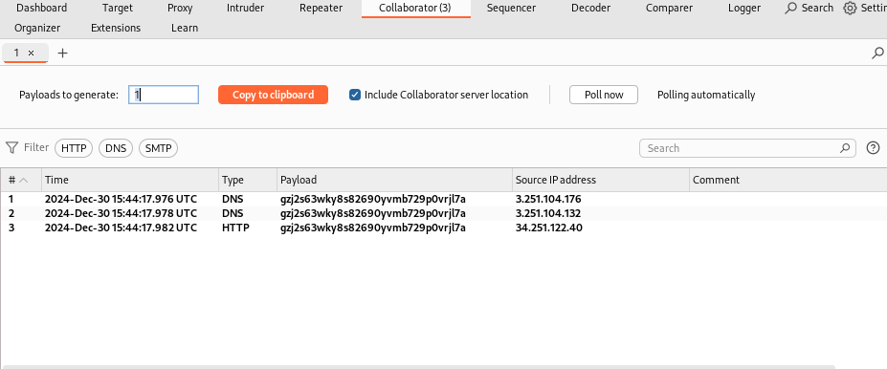

Again we get three packets here and over there we have http packet also so we can conclude that the attack is possible so now leave it here and lets go to repeater and send it to burp intruder

**Step 6:**

Now lets go to intruder

Clear all positions and change the host to given ip range in question add an exception 192.168.0.$0$

Set payload to numbers and add positions as o to 255 and start the attack

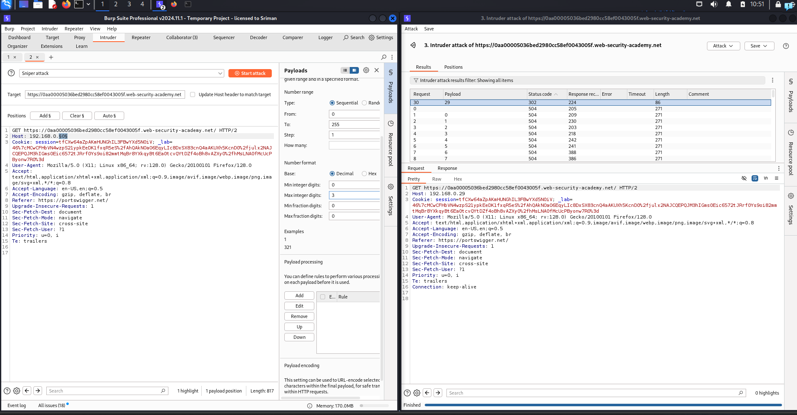

So there we found our ip at payload 29 you can see status code as 302

**Step 7:**

So that we need to send that request to burp repeater

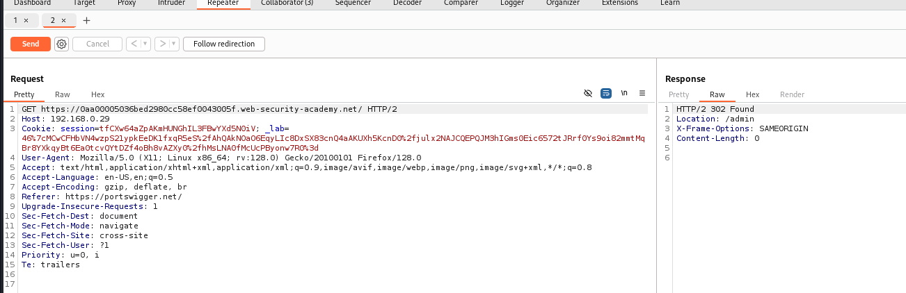

After sending to repeater send a request normally so that as above shown we get an error

**Step 8:**

In the get url add at last /admin and send the request it show as below the request is accepted

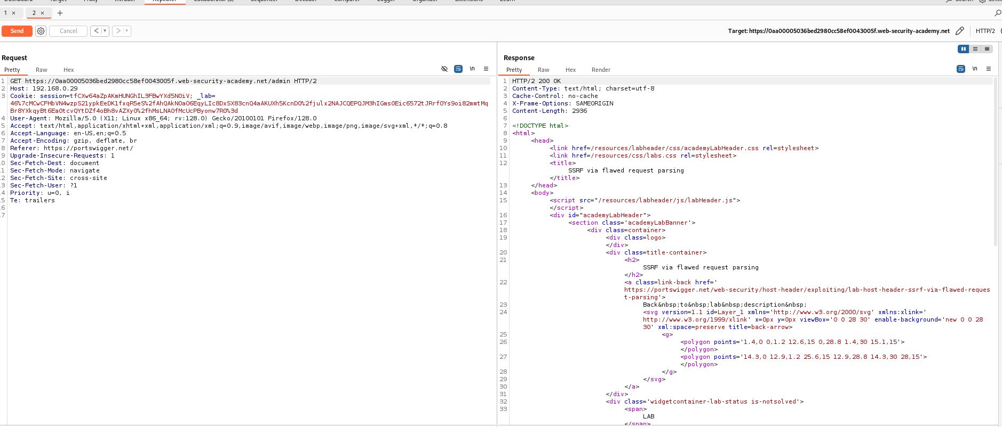

In the response you see that there we have post method to delete the user and there we see the csrf value also in the below image

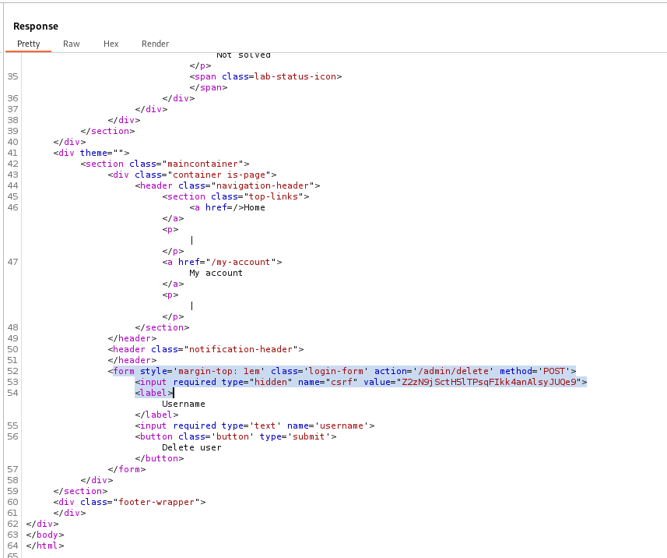

**Step 9:**

So next come to our repeater and in the get url add our sites url and at last

**/admin/delete?csrf<value of ur csrf>&username=carlos**

After adding this send the request so there you see our lab is solved we successfully deleted the carlos user…

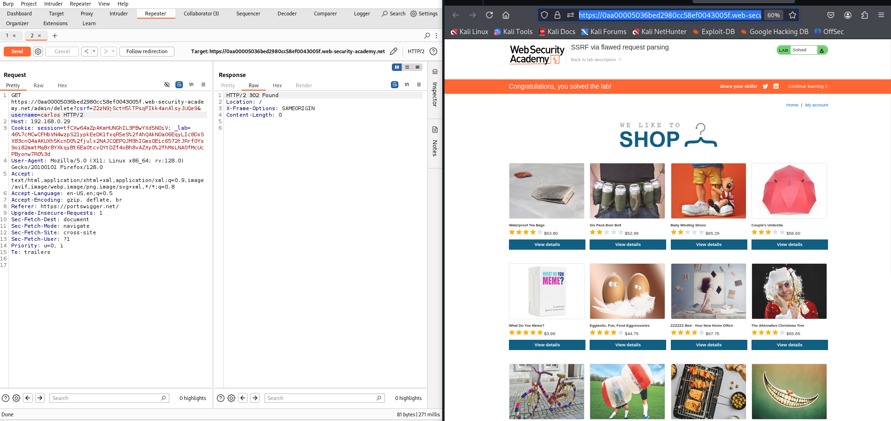

Thankyou!

# **6)Host validation bypass via connection state attack**

This lab is vulnerable to routing-based SSRF via the Host header. Although the front-end server may initially appear to perform robust validation of the Host header, it makes assumptions about all requests on a connection based on the first request it receives.

To solve the lab, exploit this behavior to access an internal admin panel located at 192.168.0.1/admin, then delete the user carlos.

**Solution-**

In a Host validation bypass via connection state attack, the server trusts the Host header in HTTP requests without proper checks. An attacker can change this header to trick the server into thinking they are accessing a trusted resource, but it processes a malicious request instead. This can lead to unauthorized access or data exposure.

**Step 1:** As it is connect it to foxyproxy burp and access the lab so there we ger an http get request so in below you can see send that to repeater

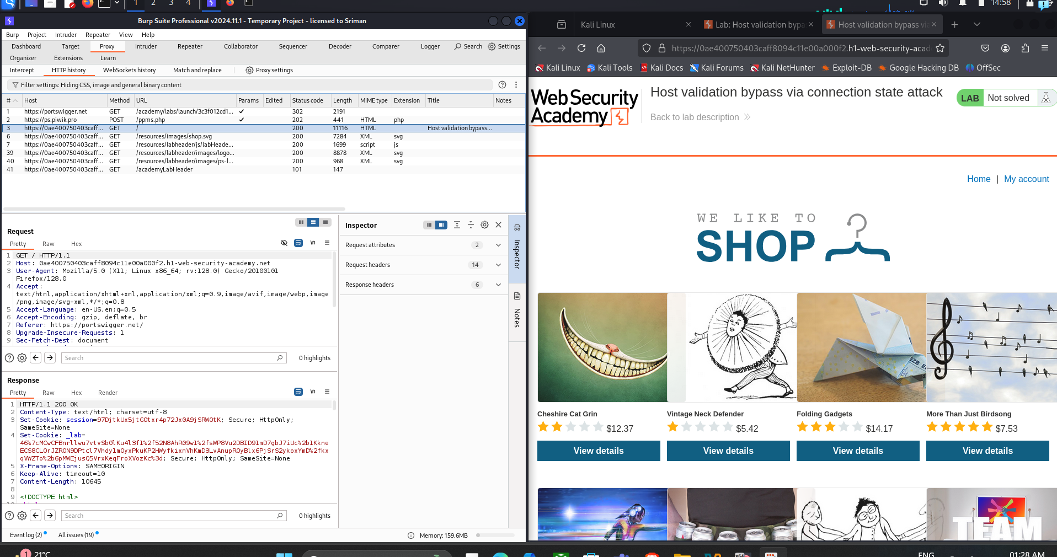

**Step 2:**

And make a copy of it which means you need to send again it to repeater so that you see two repeater in burp

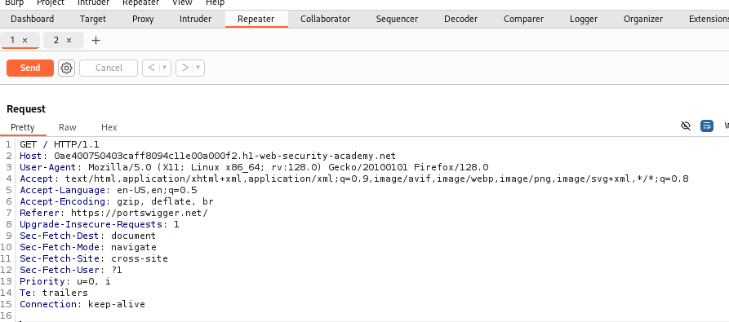

1st repeater

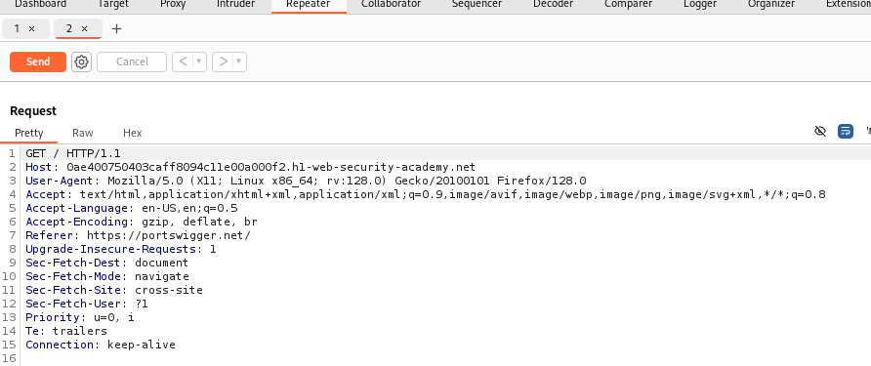

2nd repeater

**Step 3:**

So in second repeater try to access the admin panel with the given ip address whatever given in the question

Host as ip address and get url as /admin as shown in below image

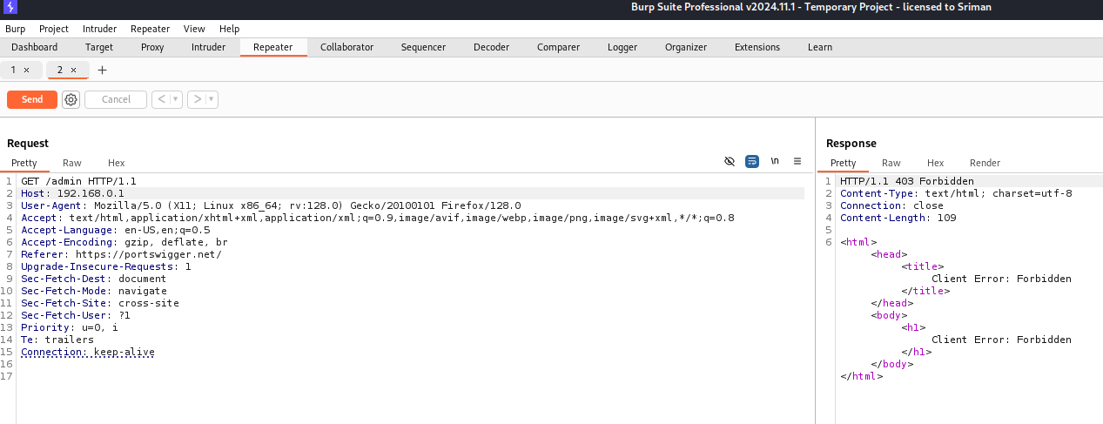

So there you can see connection as forbidden when you send the request we get a response like that

**Step 4:**

Lets make a group of both 2 repeaters

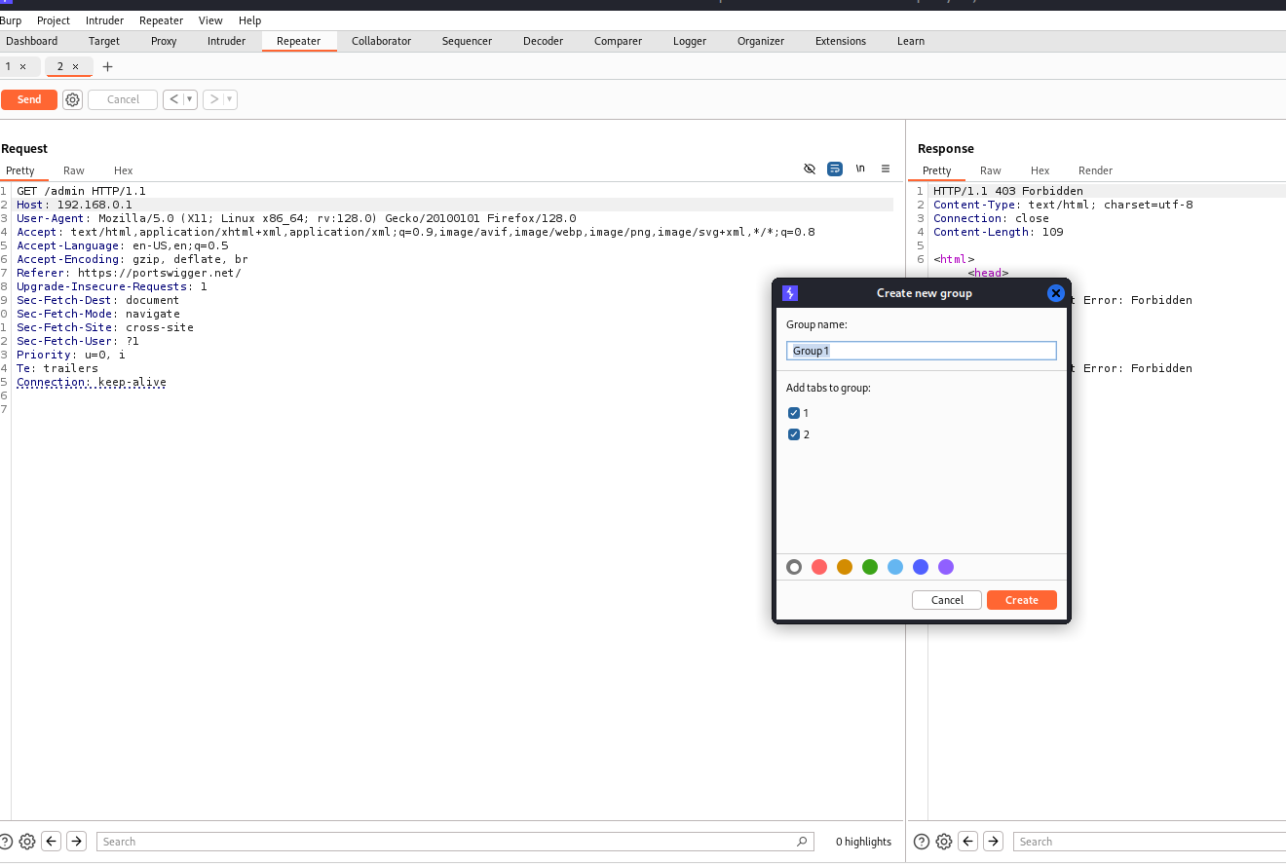

After that keep the send request as Send group in sequence(single connection)

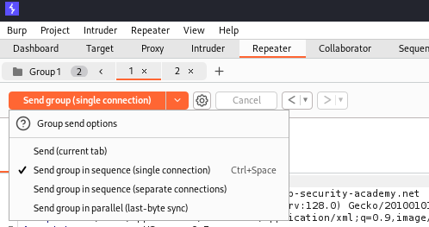

**Step 5:**

Now send request again and again until you get aa response  
(for me some times it shows like both are http1 like the error as shown)

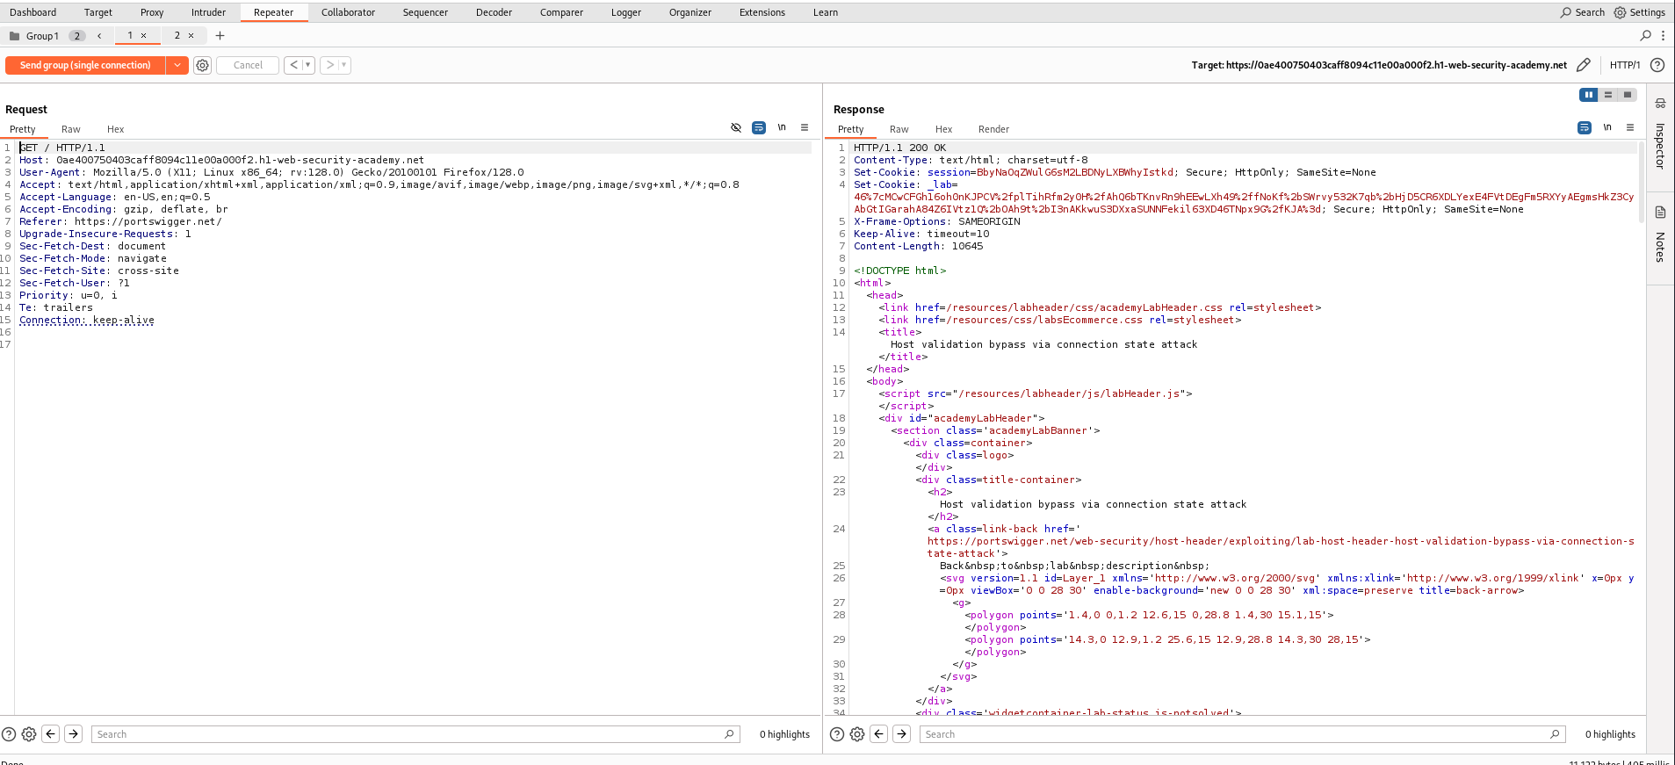

For 1st one we get the response ok

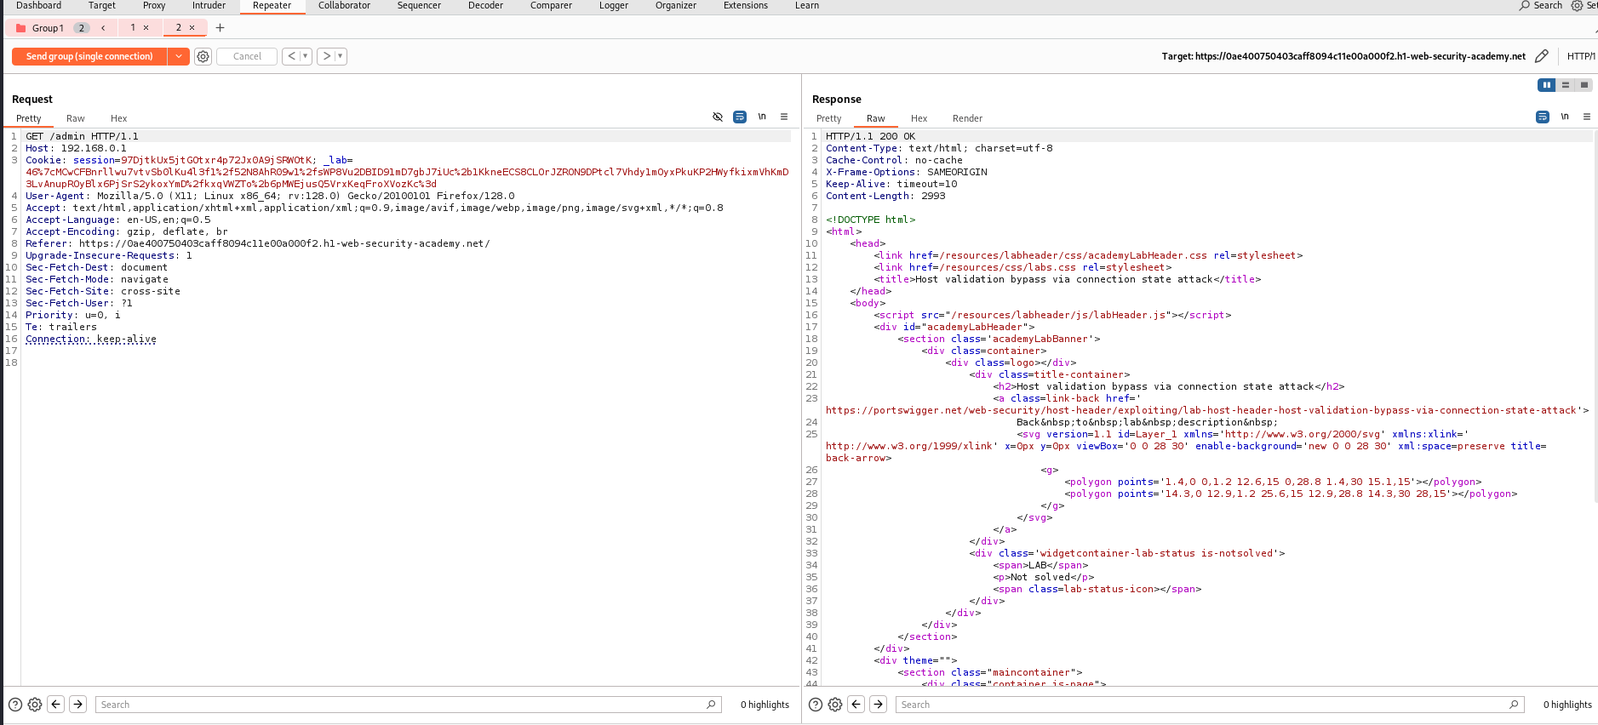

For 2nd also we are getting response as ok

So there we can see in the Raw we are getting admin/delete

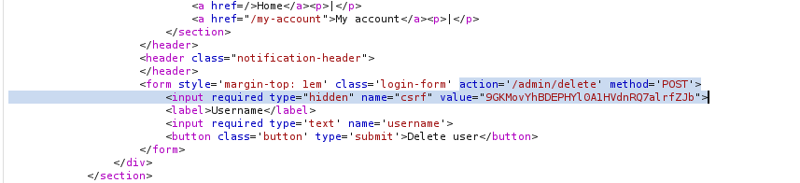

**Step 6:**

Now in the second repeater on the get url add

**/admin/delete?username=carlos&csrf=<ourcsrf token value>**

Send the request again it shows 302 found and the lab is successfully solve

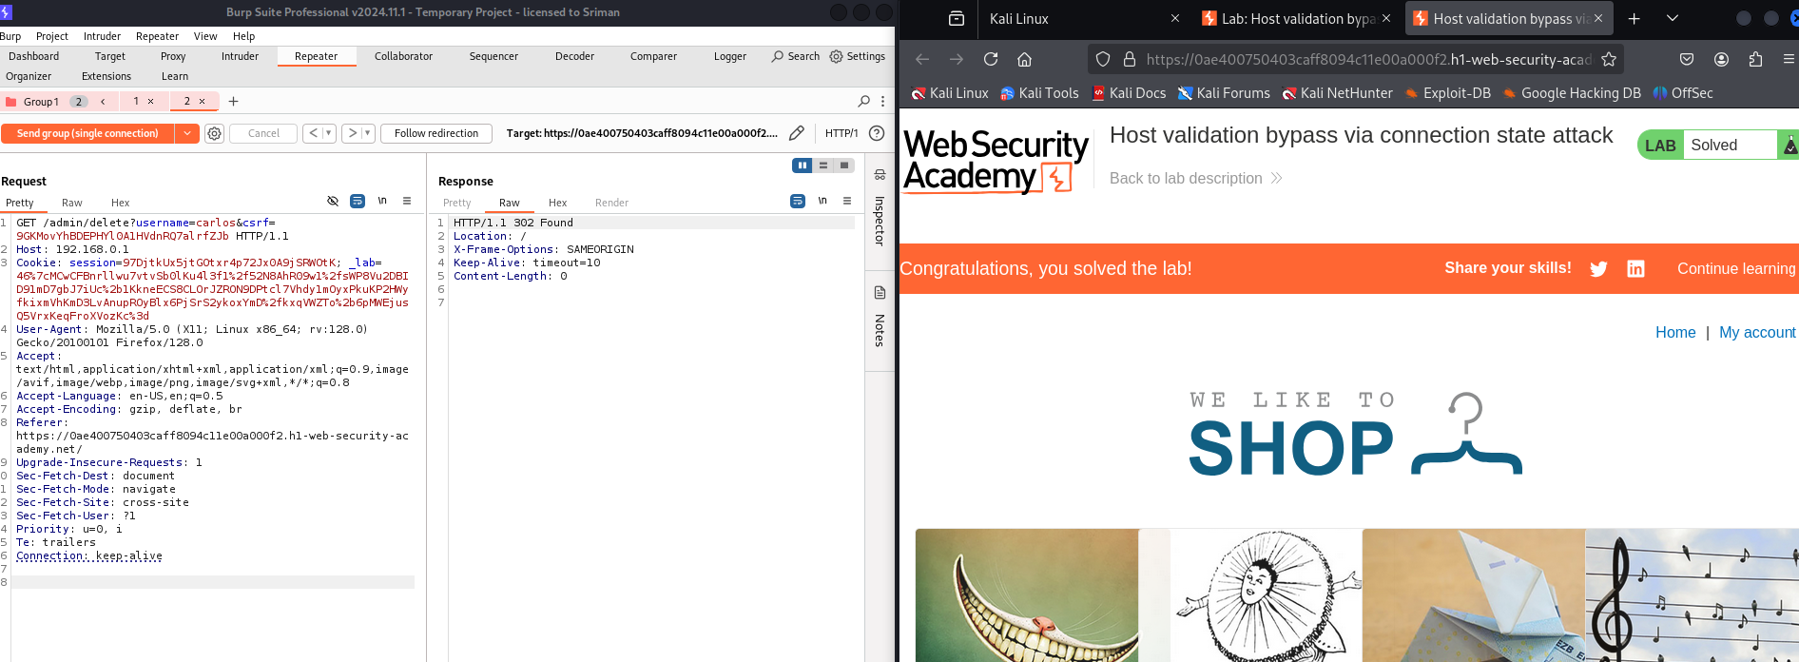

Thankyou!

Anotherway of this lab you can check this

<https://youtu.be/zTy78lVdHvc?si=-KsLuEHQ-1Z-K-47>

# **7)Password reset poisoning via dangling markup**

This lab is vulnerable to password reset poisoning via dangling markup. To solve the lab, log in to Carlos's account.

You can log in to your own account using the following credentials: wiener:peter. Any emails sent to this account can be read via the email client on the exploit server.

Solution-

**Dangling markup** refers to incomplete or improperly closed HTML tags or attributes that disrupt the intended structure of a web page or email. When attackers introduce dangling markup, they leave HTML or JavaScript open-ended to inject malicious code that the browser or email client processes incorrectly.

**Password reset poisoning via dangling markup** happens when a website sends password reset emails with a link that includes user-controlled input but doesn’t sanitize it properly.

### **Example in Simple Words:**

A website sends you a password reset link like this:  
https://example.com/reset?token=abc123

An attacker tricks the site into including malicious HTML or JavaScript in the link by adding it as part of their username or email.  
https://example.com/reset?token=abc123"><script>alert('hacked')</script>

When the email is sent, the dangling markup (like "><script>) breaks the page and runs malicious code when the victim opens the email.

Step to solve the given lab

**Step 1:**

Connect it to foxyproxy burpsuite and

Let us access the page

And goto myaccount

**Step 2:**

After that Click on forgot the password

Next give the user name as wiener and submit it

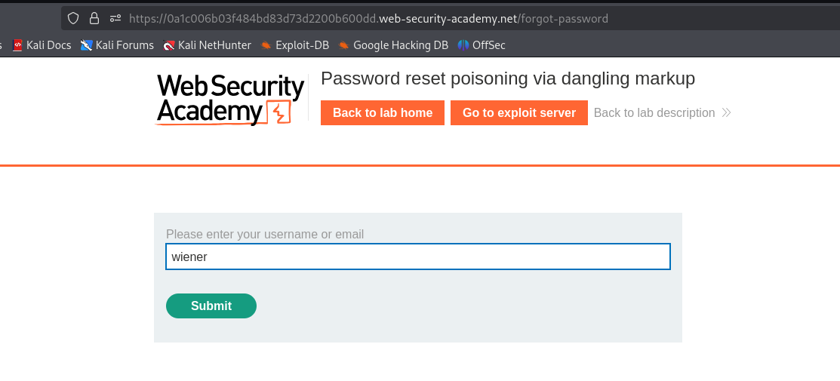

After submit it shows like bellow given



**Step 3:**

Now go to exploit server

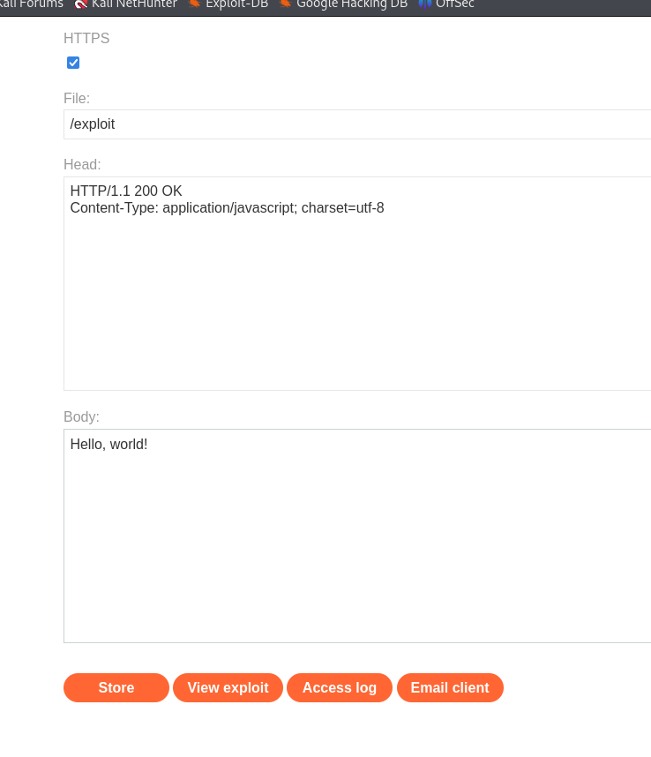

Open the email client

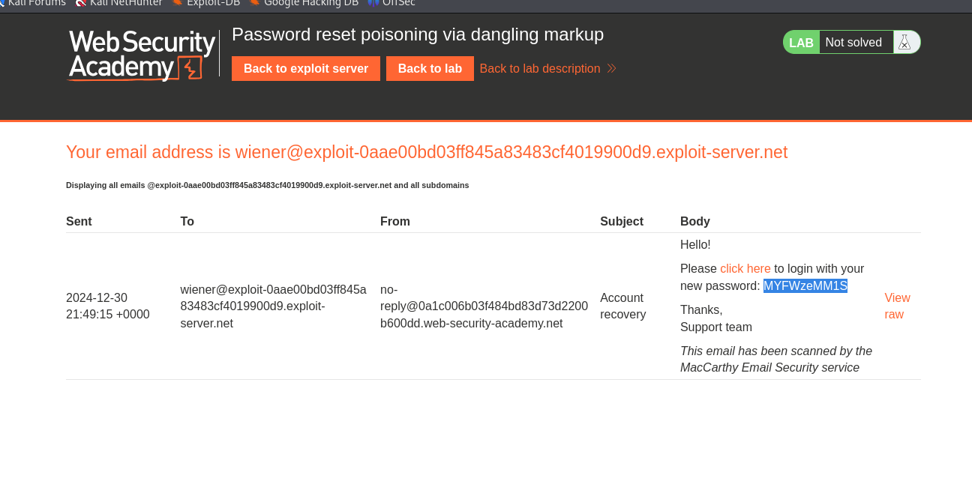

We get the password of our user wiener copy that and open login page again

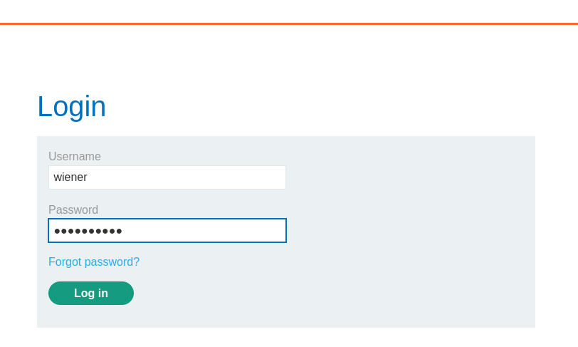  
So the password what we get on email client that you should copy

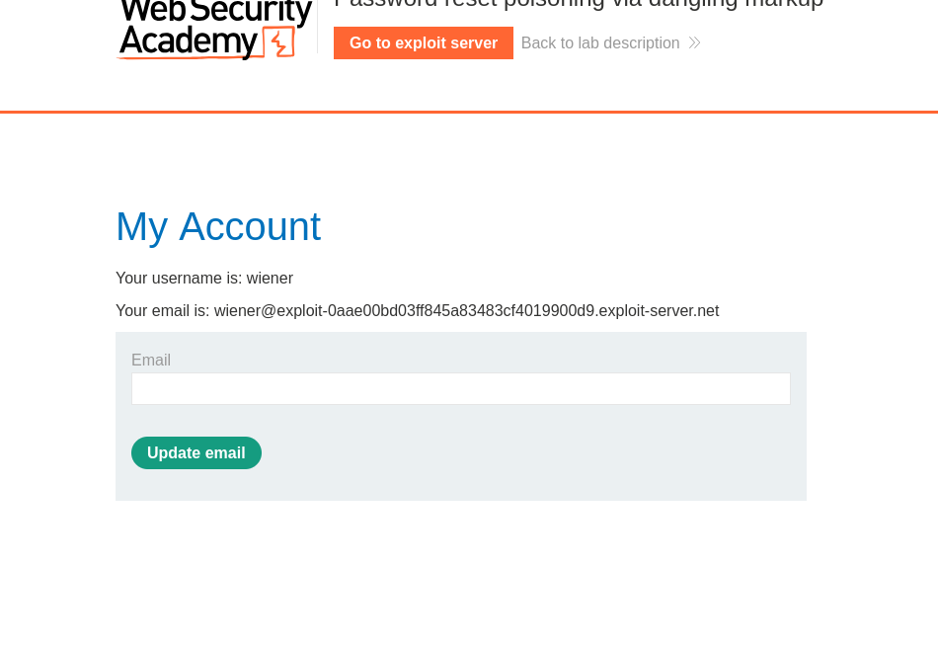

After login you get as above shown and leave over there it self

**Step 4:**

Goto burp and look for proxy in that http history so there you search for

**get/emails** response so you can see the below image we get like that

You see the java script snippet which uses the DOMpurify the library .

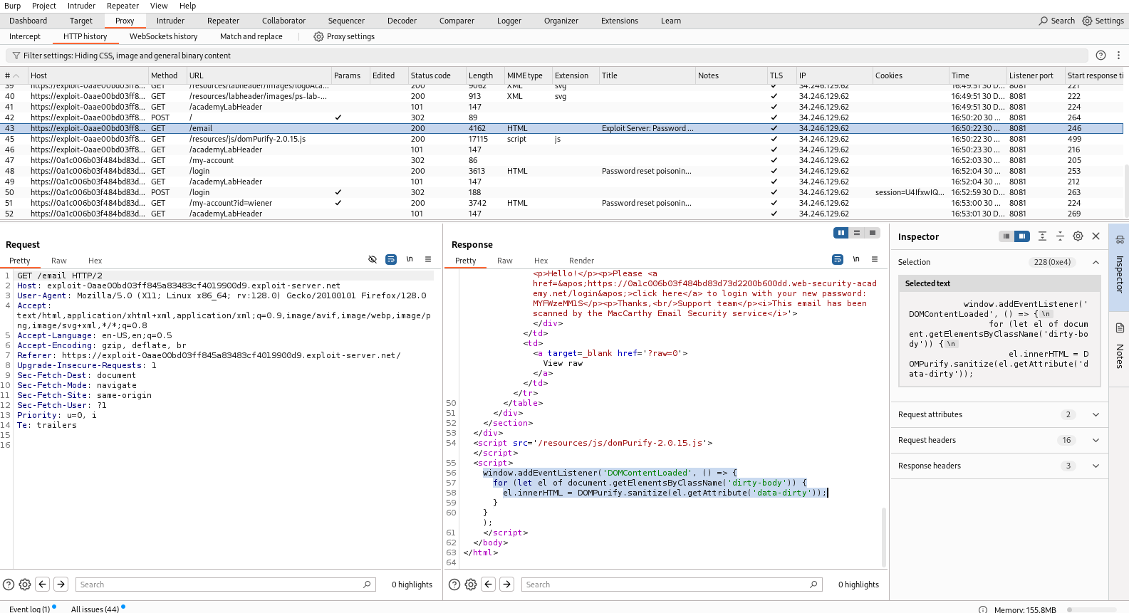

**Step 6:**

Now open the exploit server and in the email client you see an option as view raw

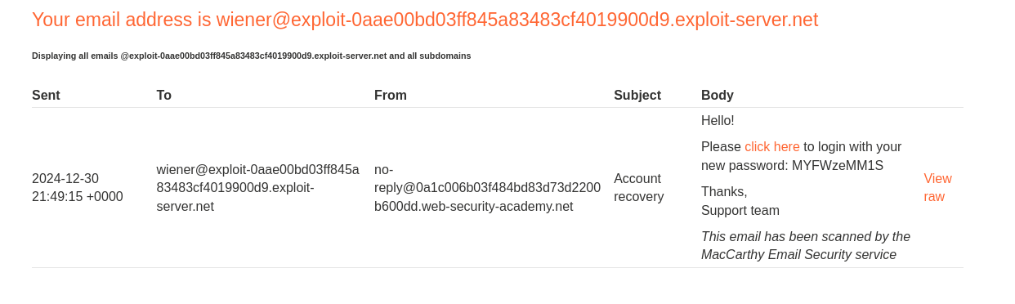

Click on view raw



And it seems like this content is not good means which is not sanitised close this.

**Step 7:**

Now move to burp and http history and look forward for

**POST request /forget-password**

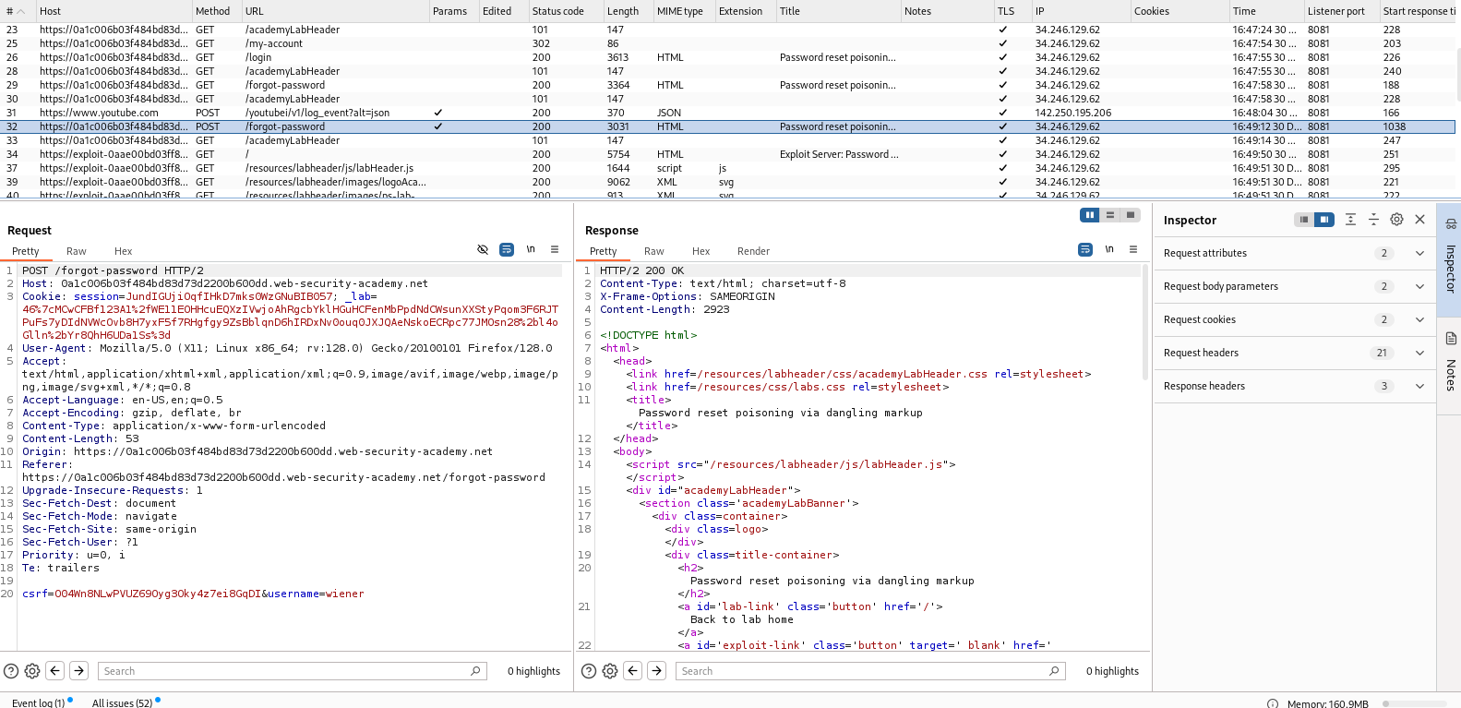

Send that post request to repeater and replace the Host header value as

Abcd1234 and send the request

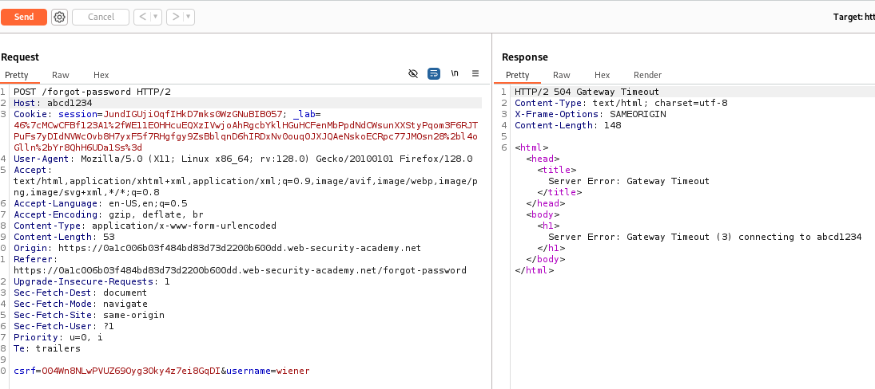

You can see that http/2 504 gateway timeout

So while im doing like this i didnt get the response as ok

**Step 8:**

**THEN I DID THAT GO TO MY ACCOUNT IN THE BROWSER AND**

**AFTER THAT USED FORGOT PASSWORD CLICKED ON THAT NEXT WHAT I DID WAS I TURNED ON THE INTERCEPT   
AFTER TURNING ON THE INTERCEPT I GIVEN THAT USERNAME AS WIENER AND CLICKED ON FORGOT PASSWORD**

**SO WHAT I GET THERE WAS**

**POST /FORGET-PASSWORD NOW I SENDED THAT TO REPEATER AND TURNS OF THE INTERCEPT AND STARTED WORKING**

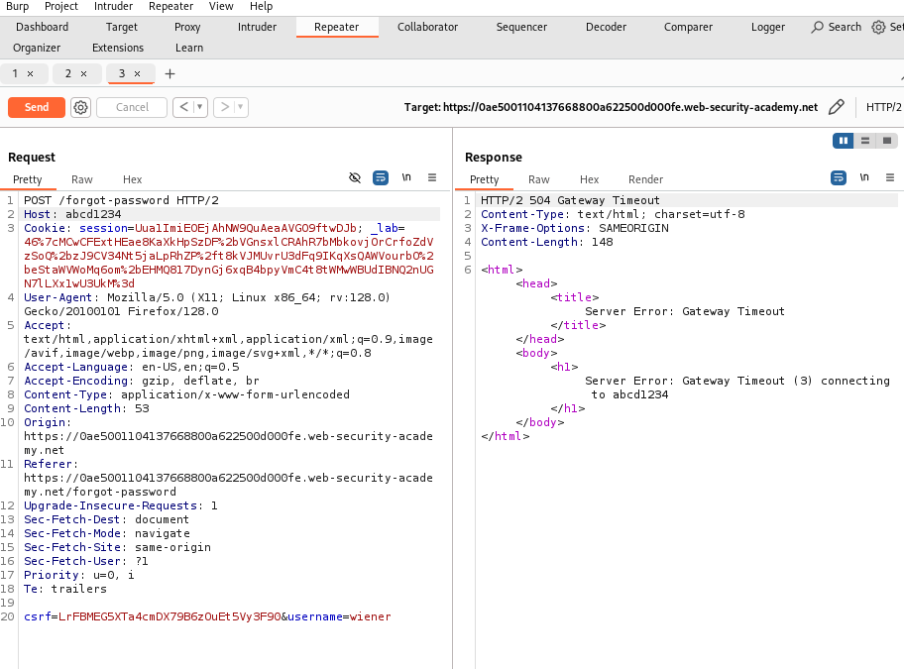

Now i change the host as abcd1234 its shows as bad gateway

So i gave back original url to it and sended so it shows response ok

Next what i did was at the end of the host added

**:hacker**

And sended the request again

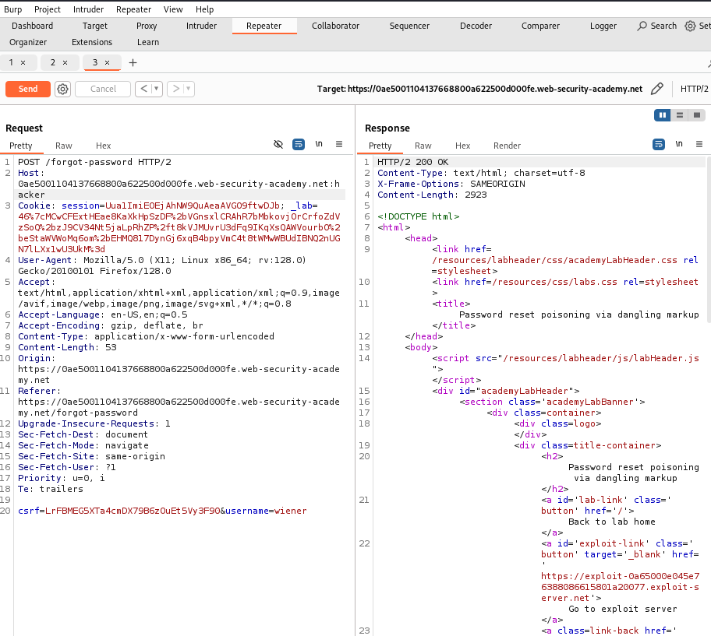

Response ok

**Step 9:**

Next move to web page and goto exploit server and search for email client and refresh that page we get like this

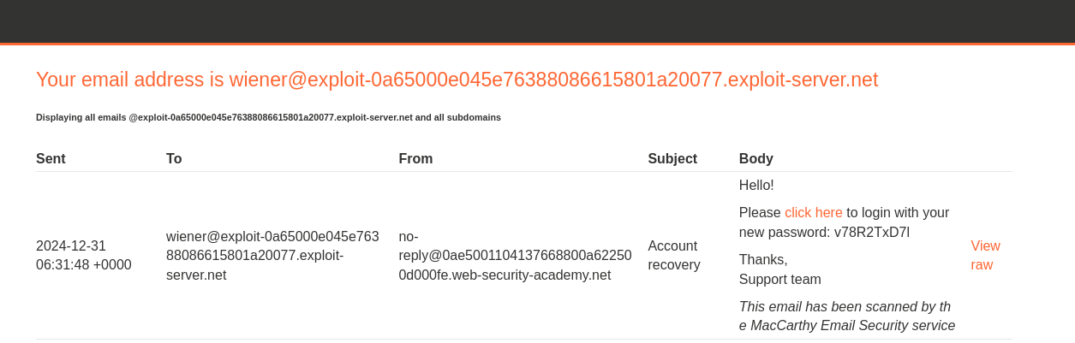

Click on view raw

  
On raw we see this

**Step 10:**

Come back to burp repeater and change the host use html tag at the end remove that hacker name and use tags of html

So like shown in the below image you need to keep in the host

After the host **.net:’<a href =”//exploit-0a19006204875010805e9dd601b5008d.exploit-server.net/?**

(exploit-0a19006204875010805e9dd601b5008d.exploit-server.net here you need to give yours exploit server url)

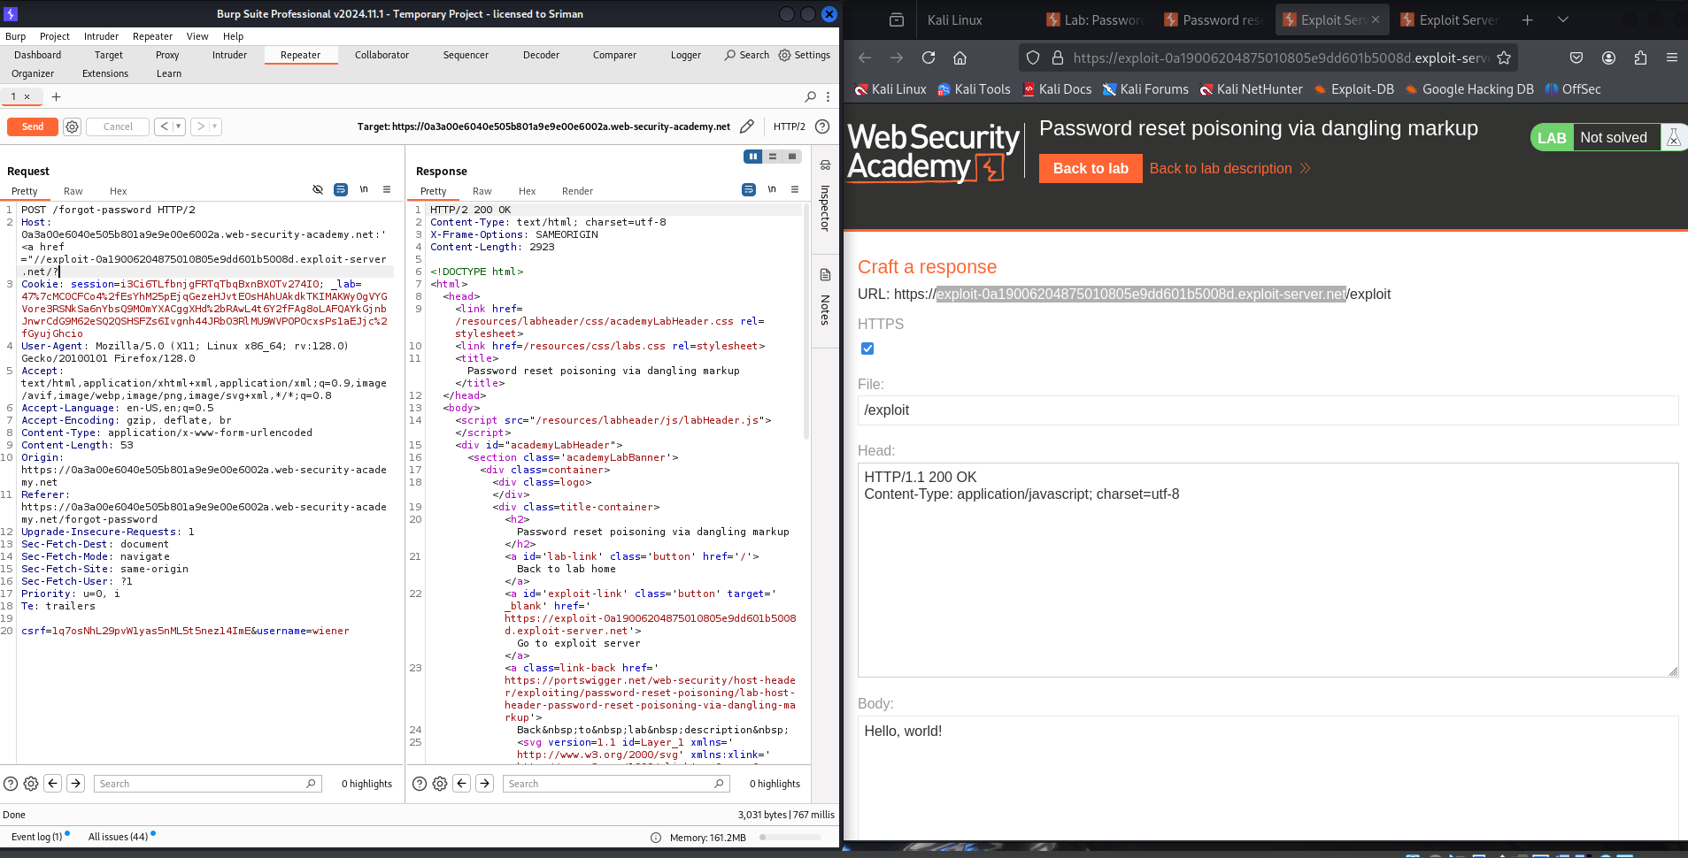

Send the request then we get response as ok

**Step 11:**

Now move to email client and there we get account recovery subject

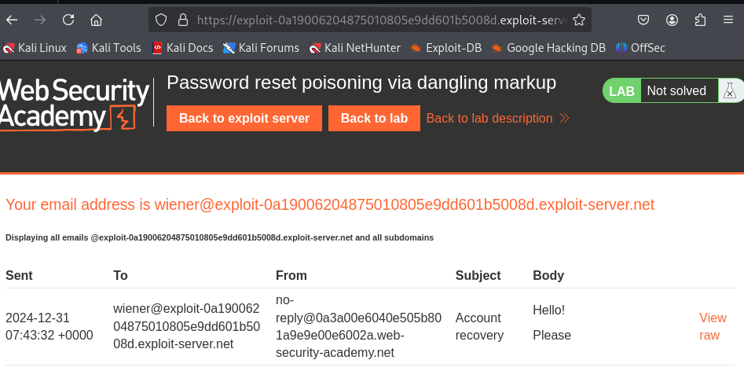

Come back to exploit server and open the access log

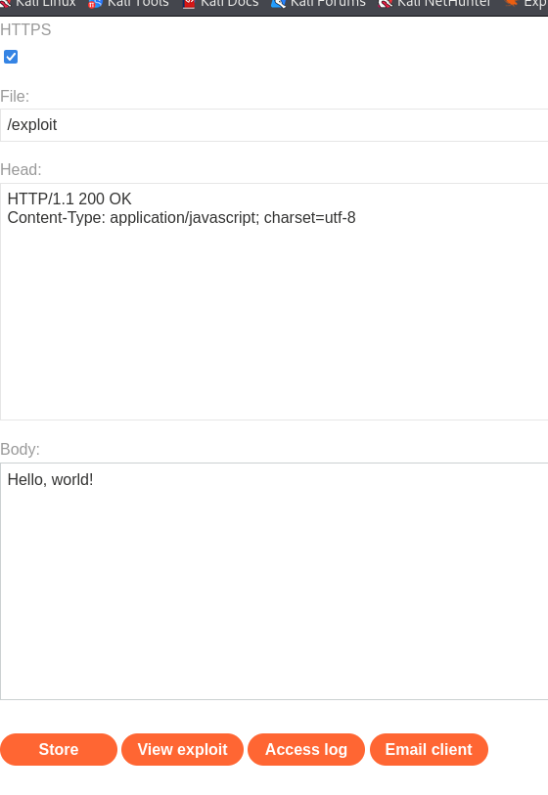

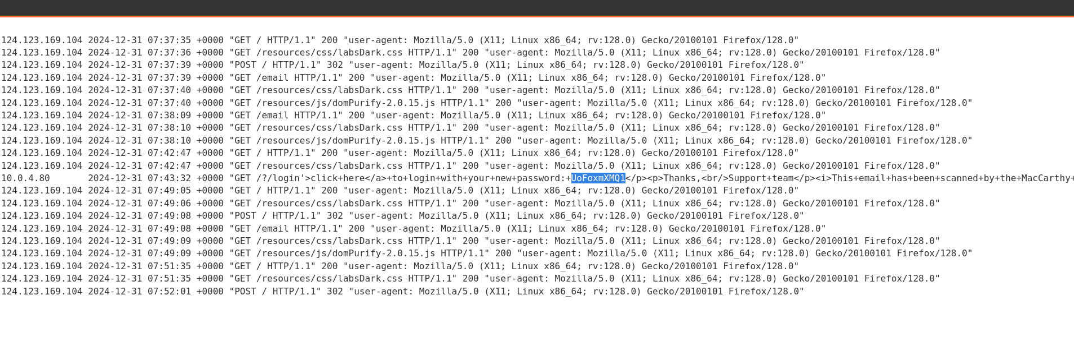

After openning access log there you get a response with the different ip address

And a new password for that so that the passwords is the user of **weiner**

**Step 12:**

Now i changed the username as **carlos**

And again i get a response as ok

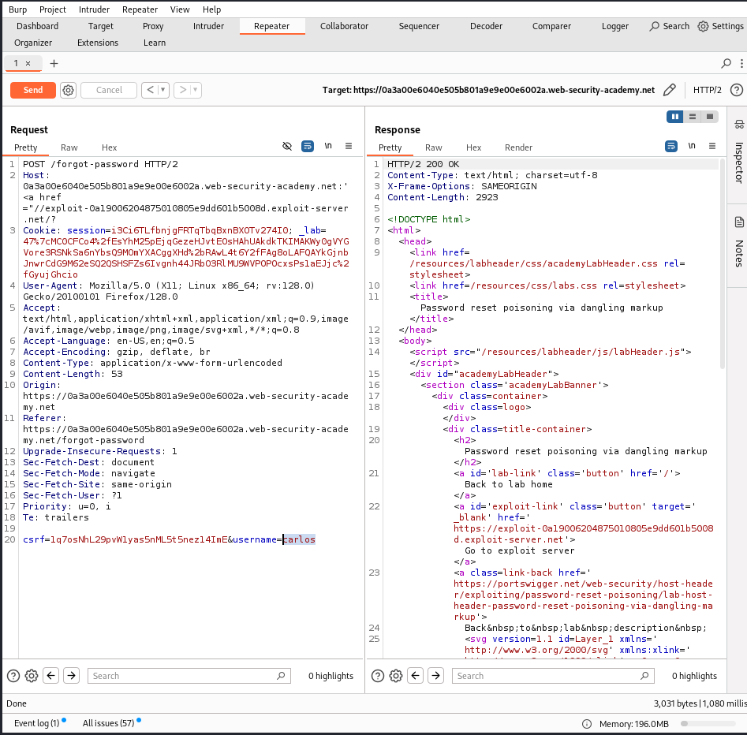

**Step 13:**

So here what i did again i went back to exploit server page and went through access log

And i refreshed the access log

And there i foundd that another new ip address as get request and i got a new password there it self as shown in the below images

So thats the password of carlos user

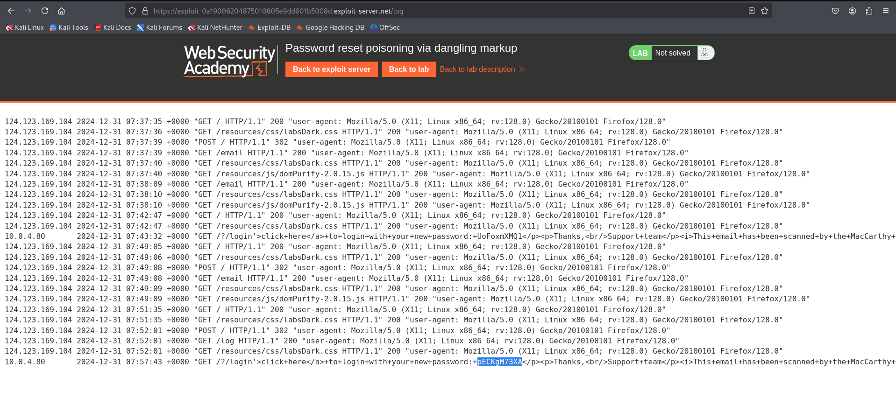

**Step 14:**

Next i login the page using that password, user as carlos

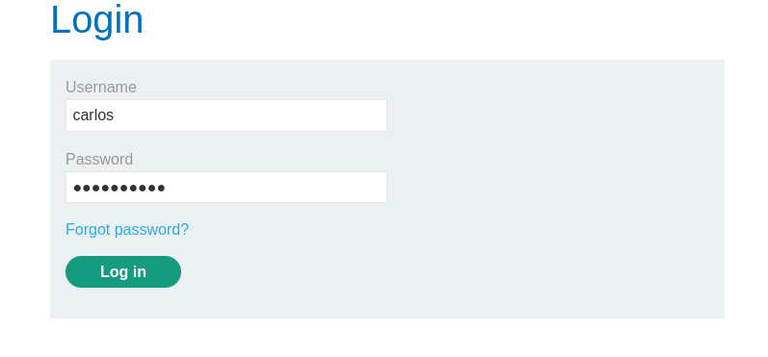

So here you can see our lab was solved

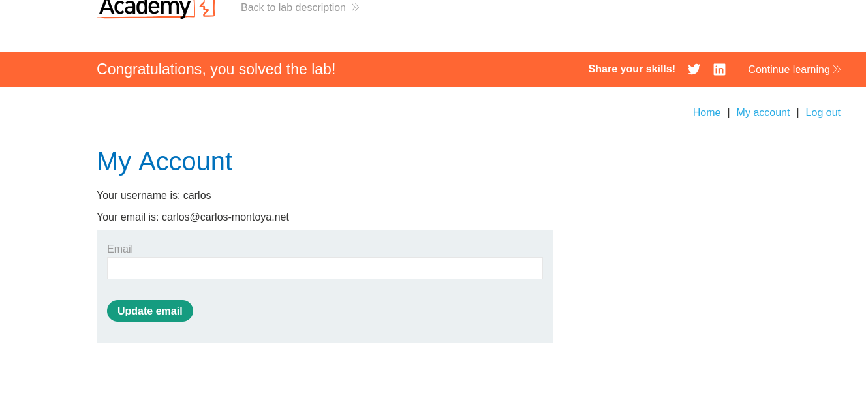

Thankyou!

So for these lab by the combinations of to things i have done those are

<https://youtu.be/s6t2P1RWdxU?si=wf-Ern7hqMUGdfPn>

And

The community solution of portswigger

**Reference for all lab solutions and about HTTPS HOST HEADER ATTACK:**

<https://portswigger.net/web-security/all-labs#http-host-header-attacks>